**SFCC Training Exercise Sheet**

**Day-1**

1. Import SiteGenesis and SiteGenesis global sites into your sandbox
2. Import RefArch and RefArchGlobal sites into your sandbox

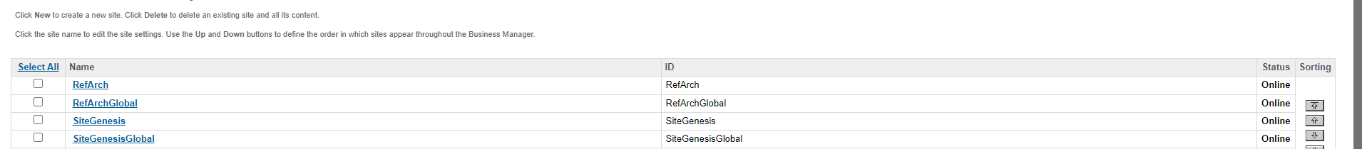

**Day-2&3**

1. Create your own site with the id “***demosite***” via BM
2. Build a navigation structure (Storefront Catalog) for a new site
3. Create a Category “Sony” and make sure all the products which have brand value as “Sony” should be assigned to this category dynamically (hint: use categorization rules)

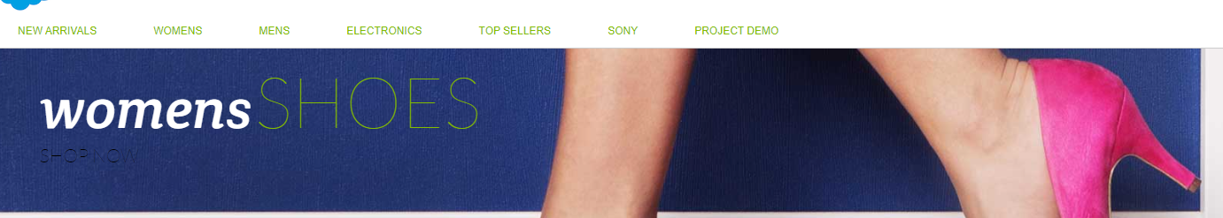

1. Make the “EARRINGS” category offline

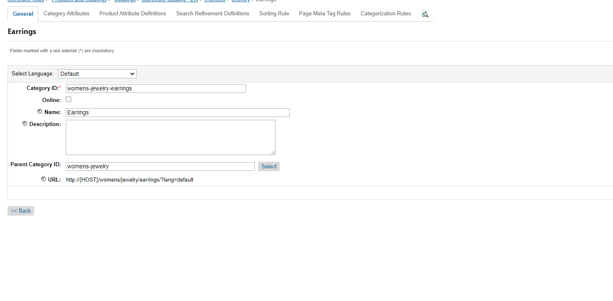

1. Update the parent of the “Shoes” (Womens -> Accessories -> shoes) category to New Arrivals

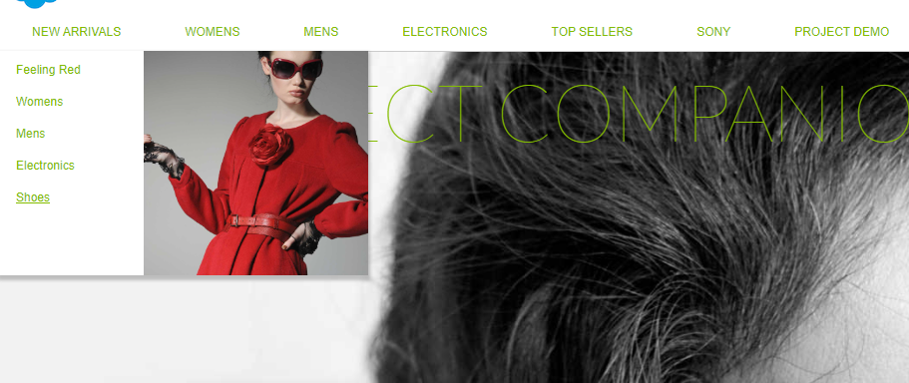

1. Copy “Feeling Red” (Womens -> Clothing -> Feeling Red) category to New Arrivals Category

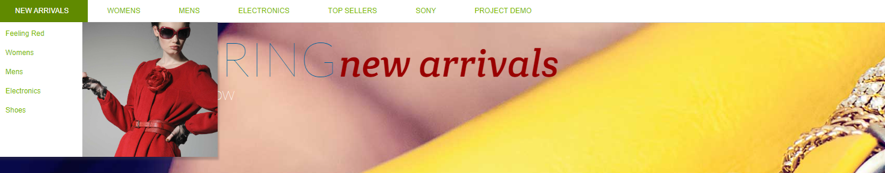

1. Create a new category “Products Demo”
   * 1. ->Create a Master Product and assign it to the “Products Demo” Category

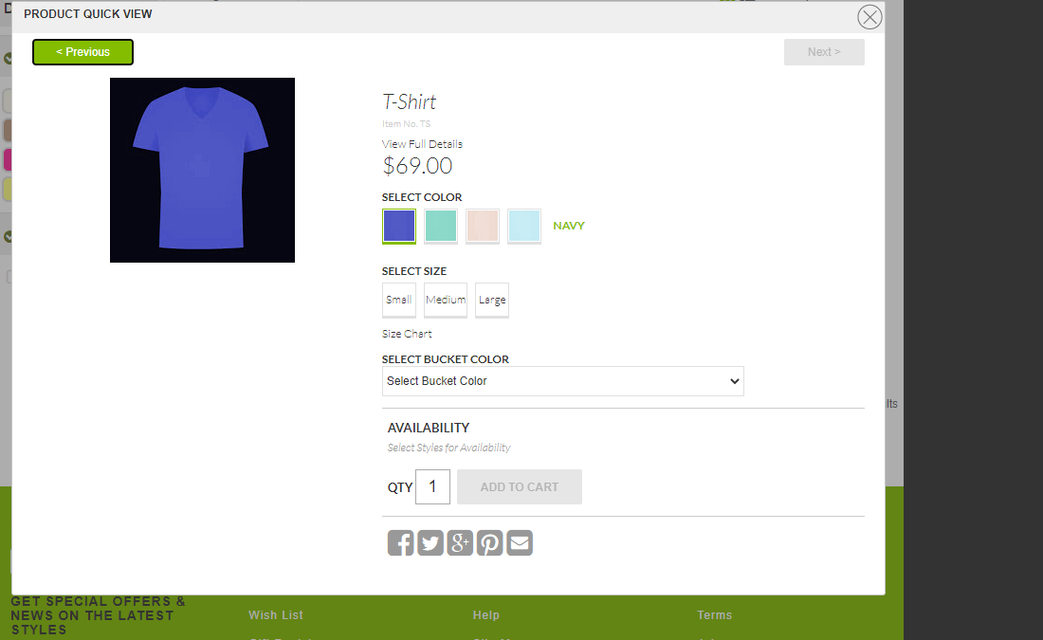

1. Explore any two existing product bundles and product sets. Create your own product set and product bundle, and assign those to the “Products Demo” Category

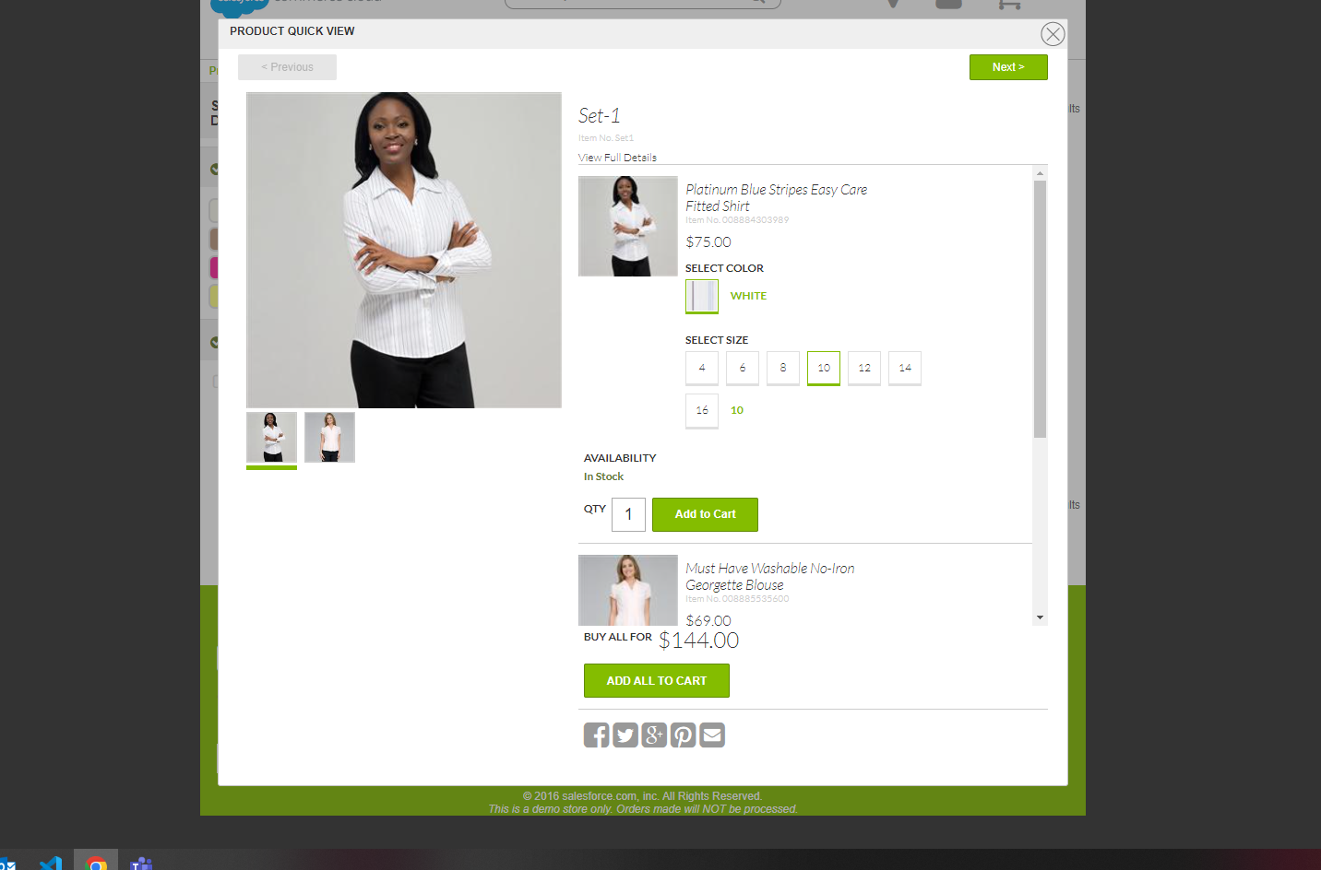

1. Explore any 2 existing product options and add new values to those product options

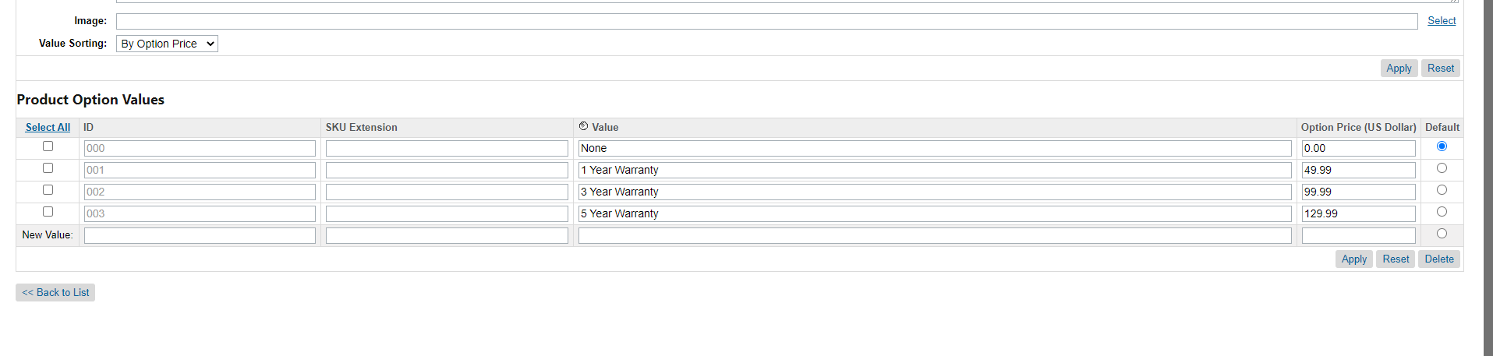

1. Explore any 2 existing variation attributes and add at least 2 new values to those variation attributes

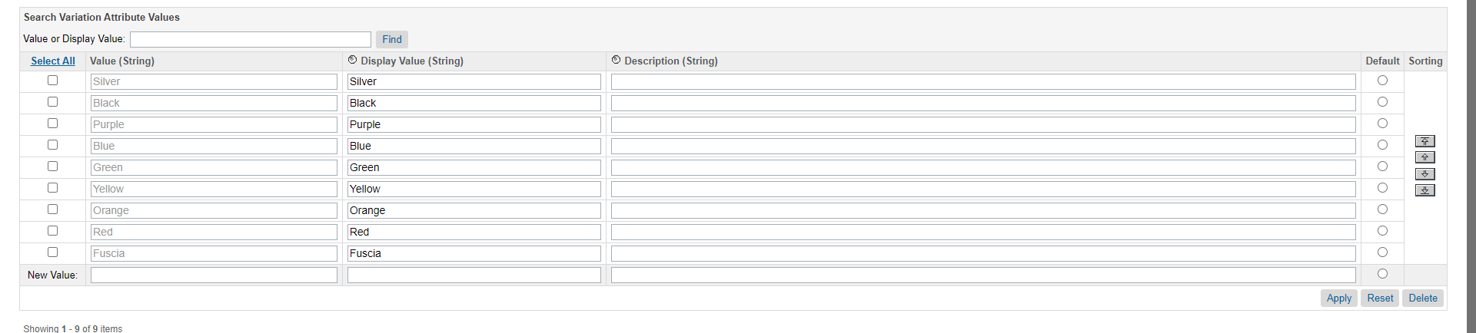

1. ***Use Case***: Marchant wants to let customers refine products based on whether a product is trending or not

* Create an “isTrending” custom attribute to the Product System Object Type (type “Boolean”)
* Make the attribute available for merchandising team to view and edit
* Define a Search Refinement based on the "isTrending" attribute
* Perform the bulk edit to give the value "yes" for some products
* Perform the bulk edit to give the value "No" for some products
* Configure the buckets for the search refinement definition created above to make sure that “yes”, “no” values are displayed to the shoppers instead of “true”, “false”

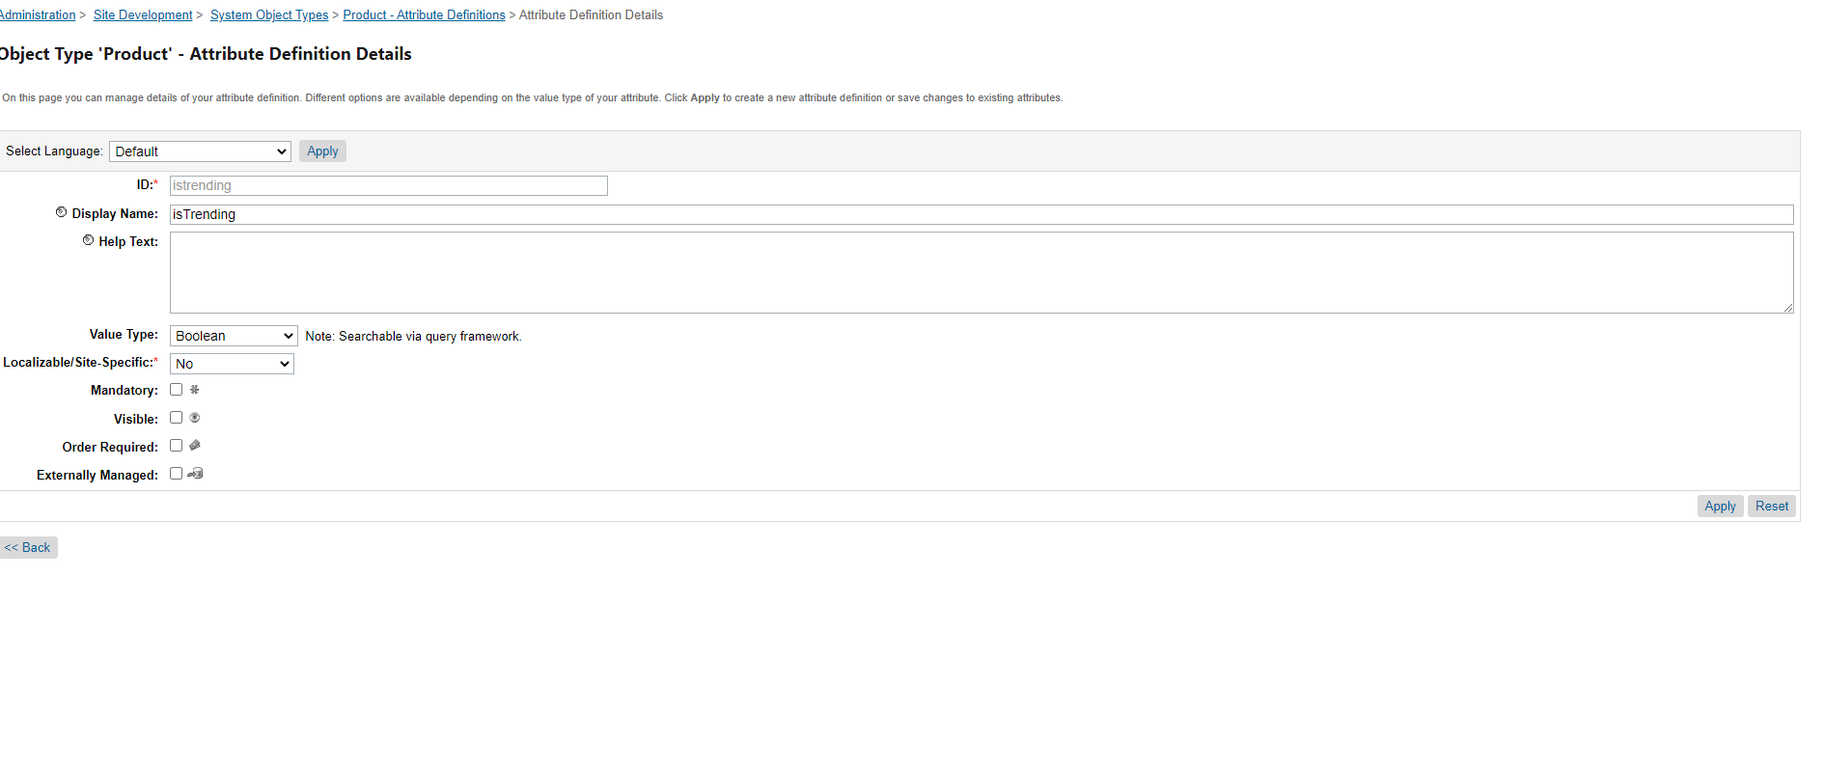

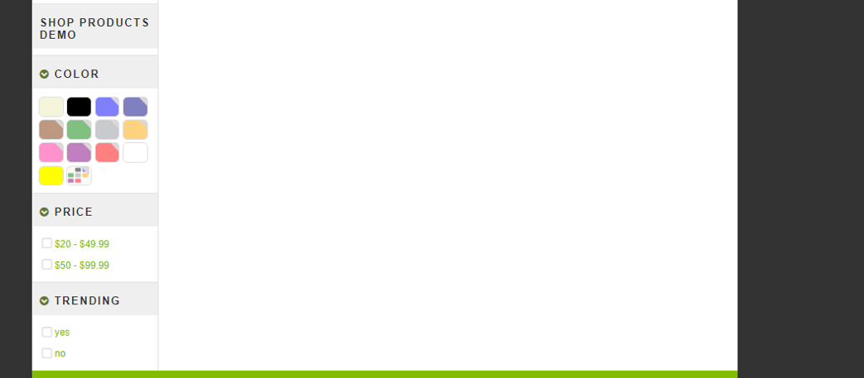

1. Adjust the Price Search Refinement Definition for the category “Womens -> Clothing -> Tops” to make sure a shopper is able to filter products in the threshold of $100 - $299.99

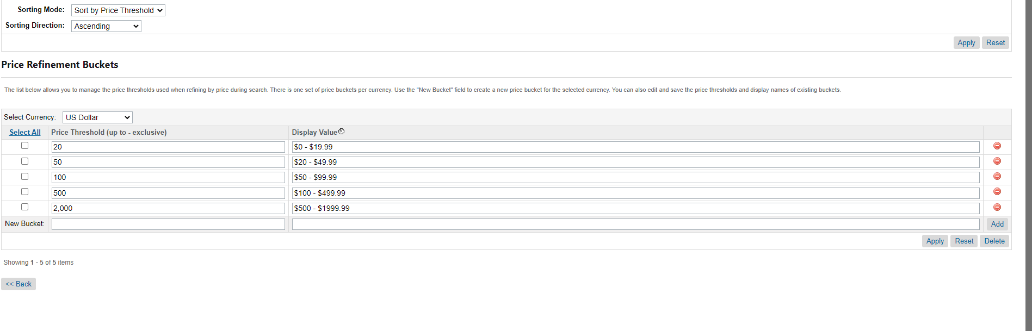

1. Define the price for a product in two price books and make sure both price books are activated and assigned to your site. Check the price on the storefront

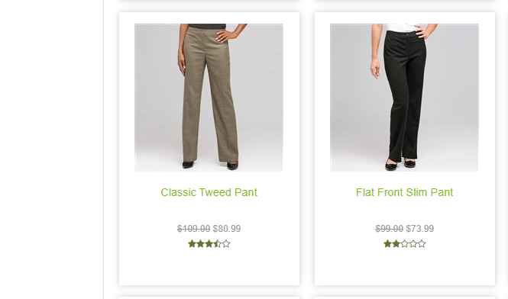

1. Make any product always available on the storefront (Inventory)

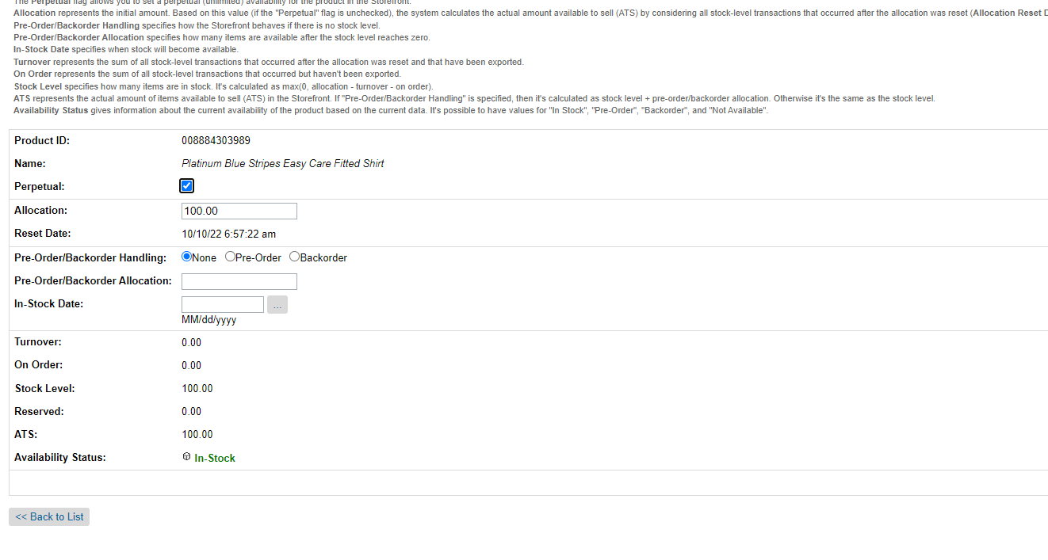

**Day-4**

***Use case:*** A Merchant wants to let customers search for products based on material type

1. Make product Material(materialTest) attribute a searchable attribute
2. Bulk edit to provide value for the material attribute for some products
3. Rebuild the search index
4. Check the changes on the storefront

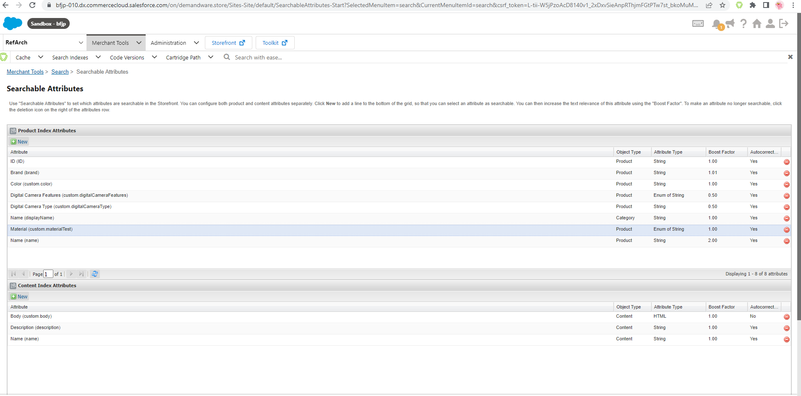

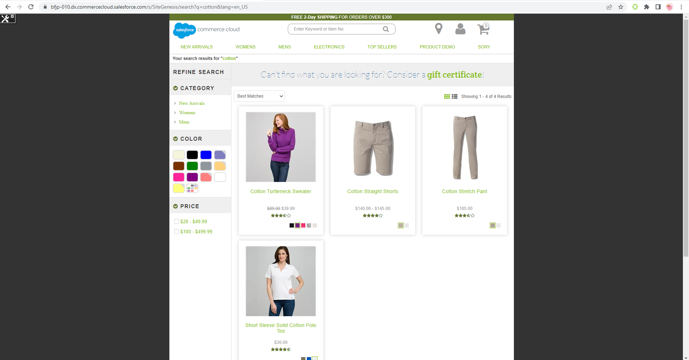

1. Disable Incremental search index for synonym index

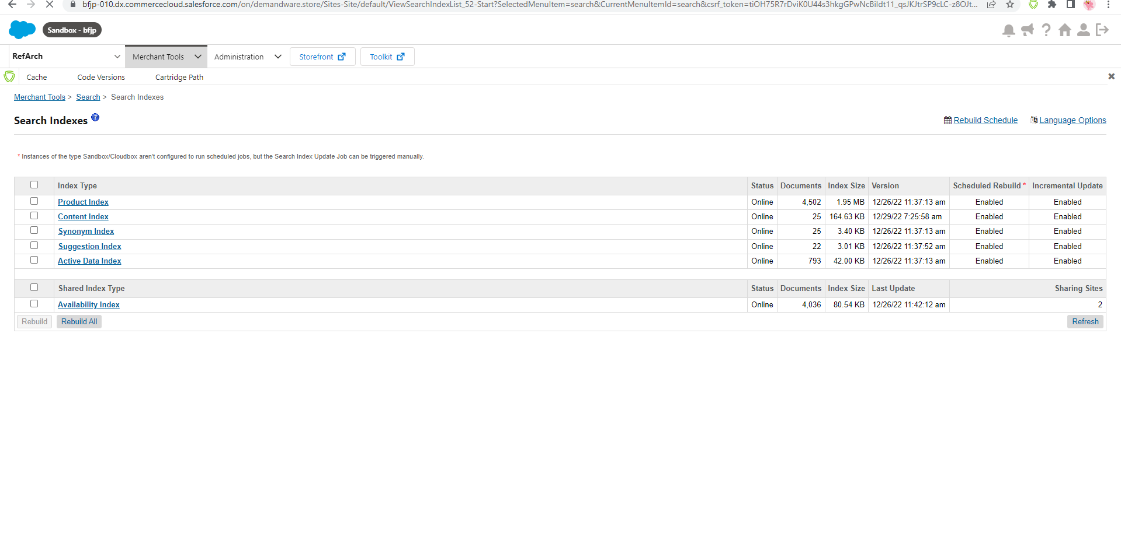

1. Override the default sorting rule for the category "shorts" (any other category is also fine)

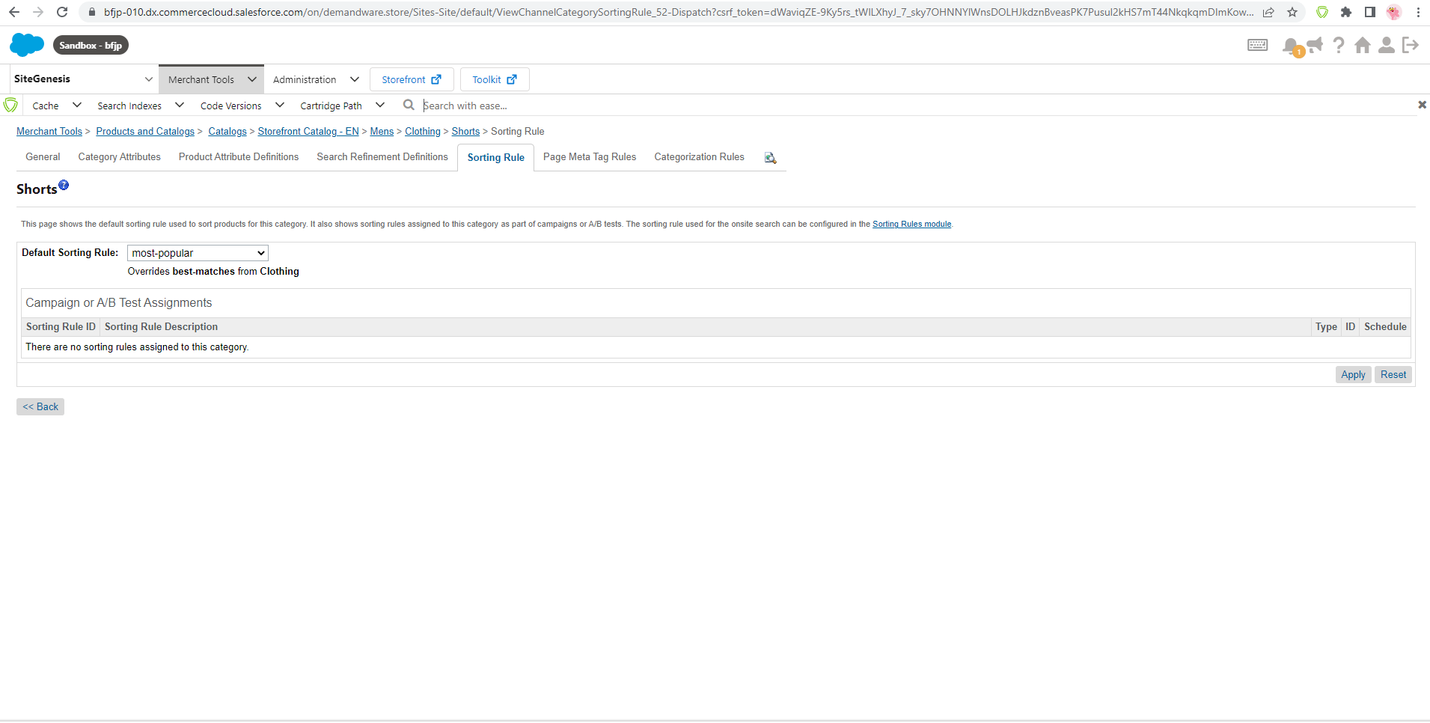

1. Override the default sorting rule for the search terms "shirts, pants, camera"

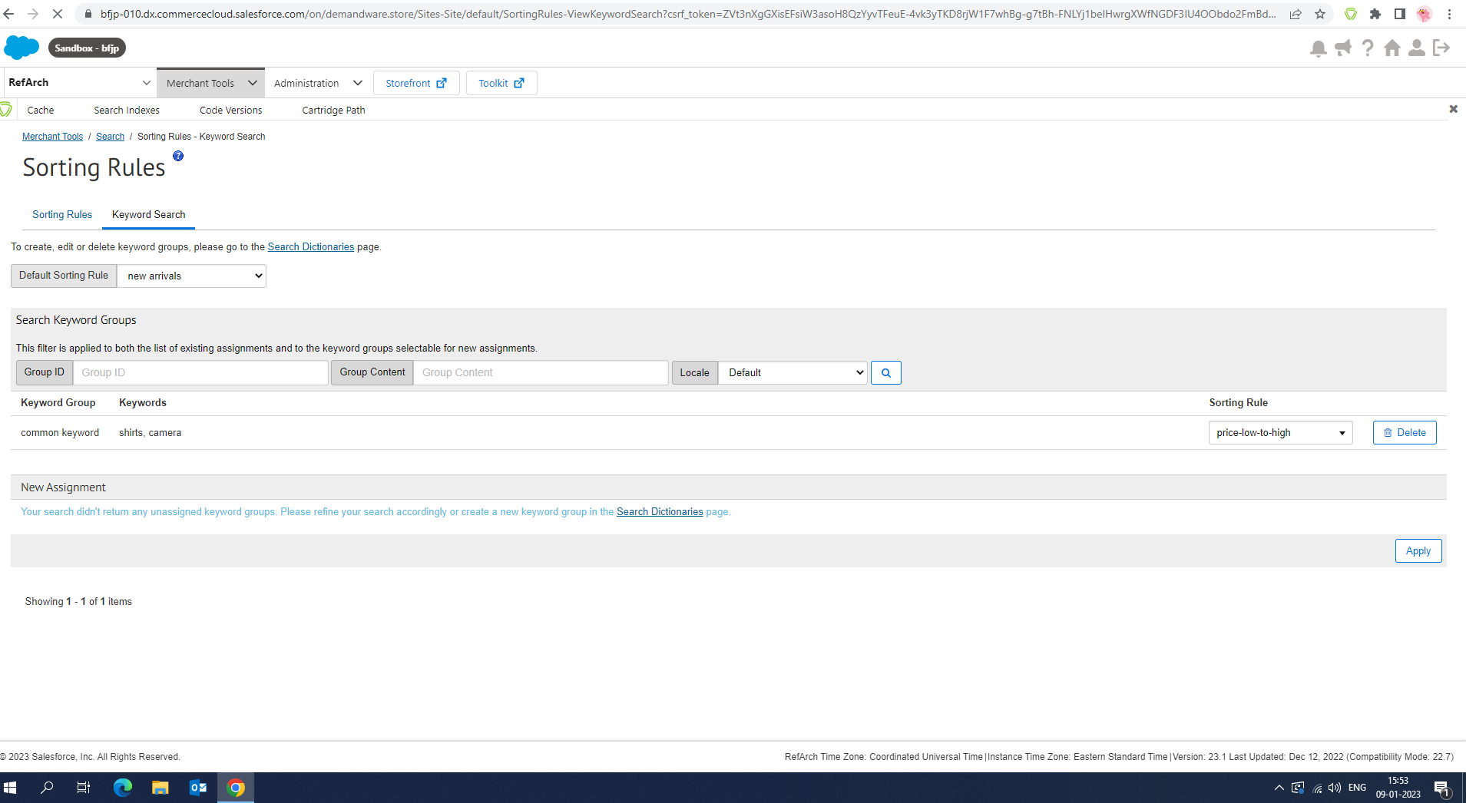

1. Create a sorting rule by using category position and text relevancy attributes

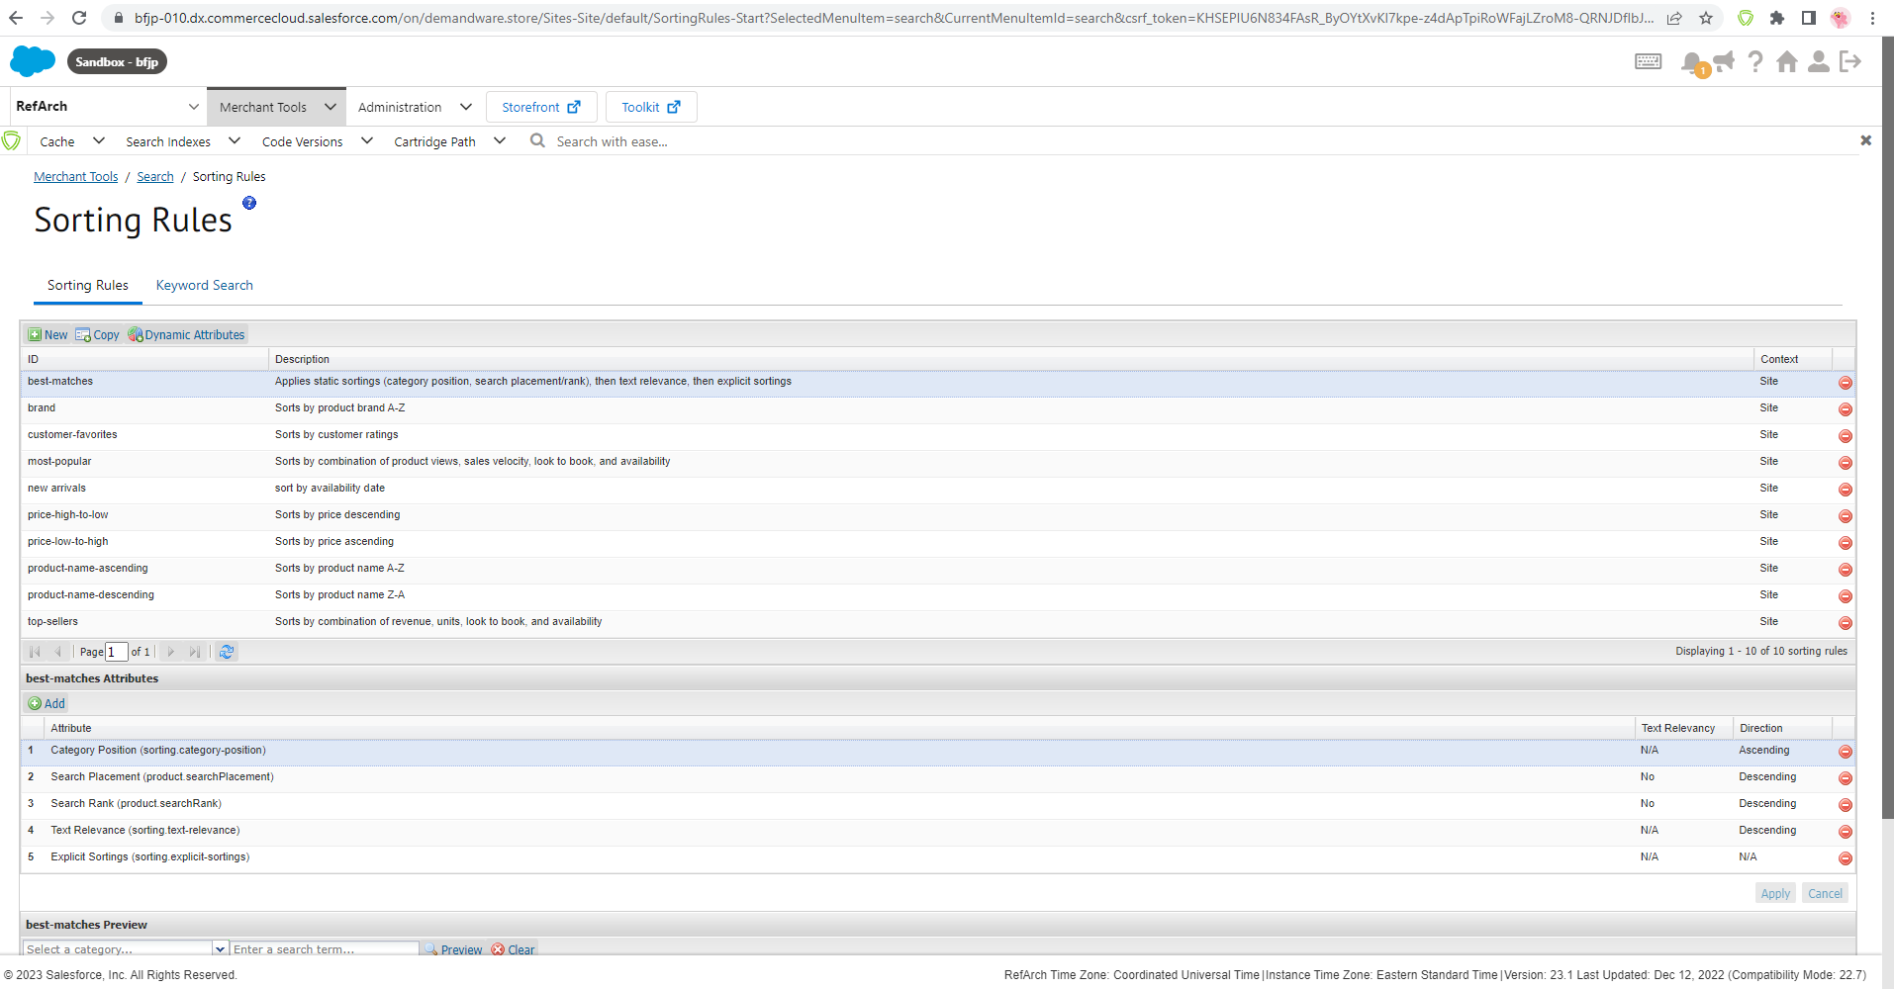

1. Pick some products to show on the top of the search results for a "tops" category (Category position)

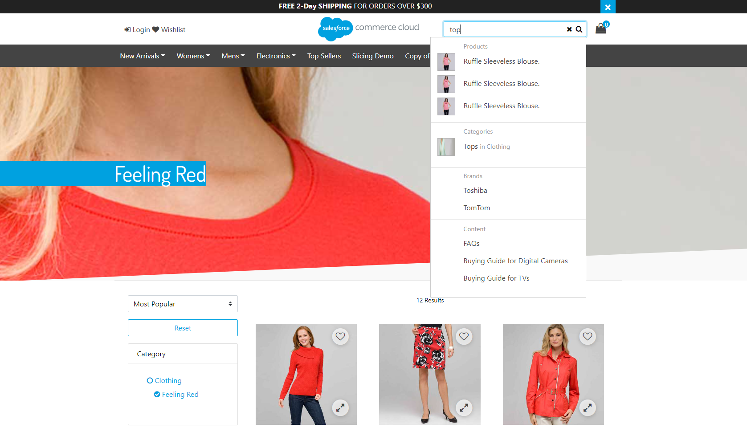

1. Block the price search refinement definition for the Electronics → Televisions category

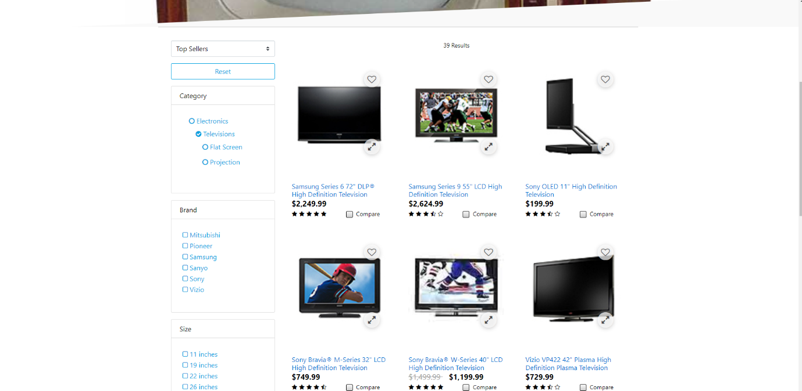

1. Configure search redirect for the “**red**” keyword to make sure it is redirecting to the “[FEELING RED](http://production-sitegenesis-dw.demandware.net/s/SiteGenesis/womens/clothing/feeling%20red/?lang=en_US)” category

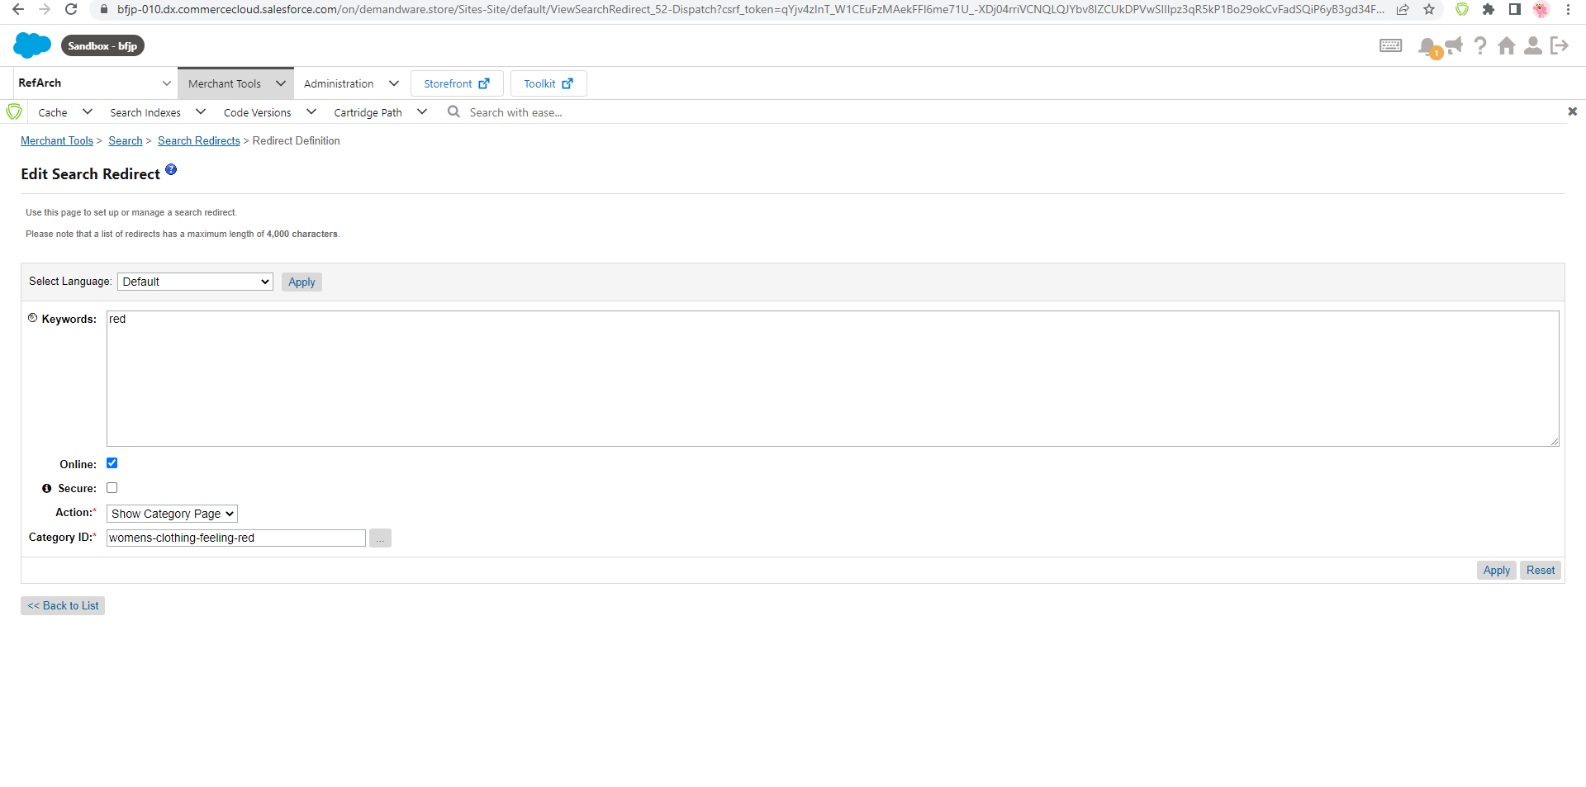

1. Configure the search settings to make sure it returns only orderable products in search results

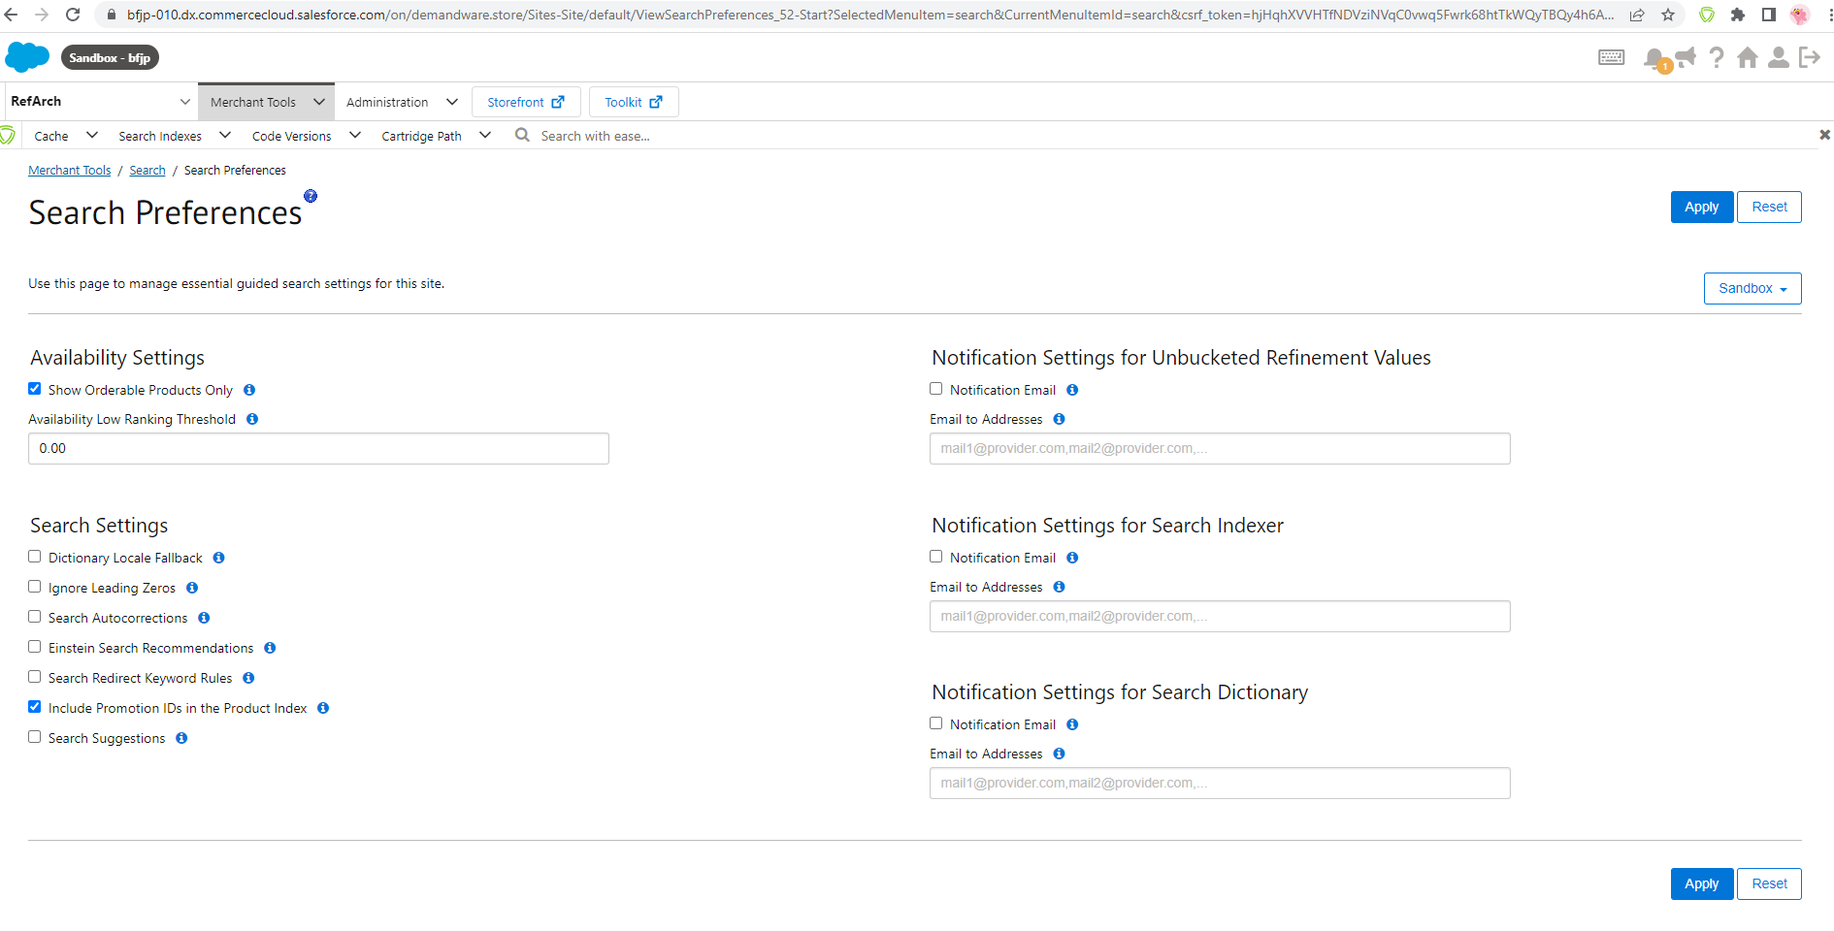

**Day-5**

1. Extend any system object type (Ex: Product system object type)

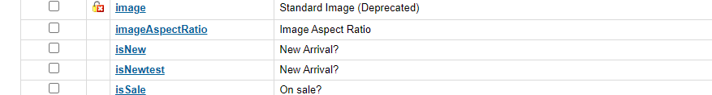

1. Create a Custom object type “NewsletterSubscription” to store the shopper info who subscribed for a brand newsletter
2. Define the following attributes in the “NewsletterSubscription” table

* email
* firstName
* lastName

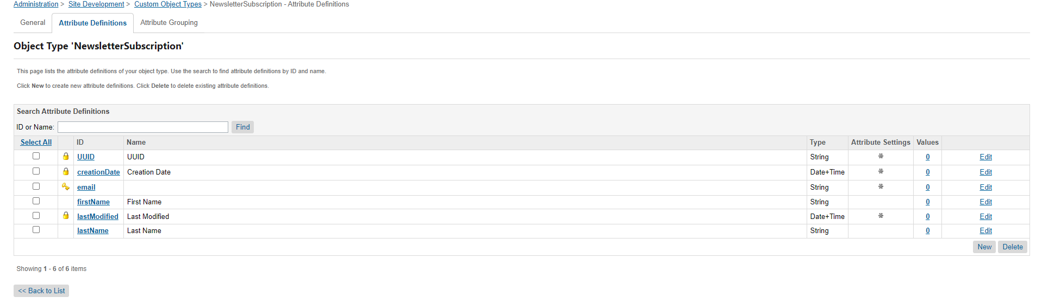

1. Insert at least 2 records into the custom object type created above



1. Create a new site via BM and disable caching, disable storefront URLs

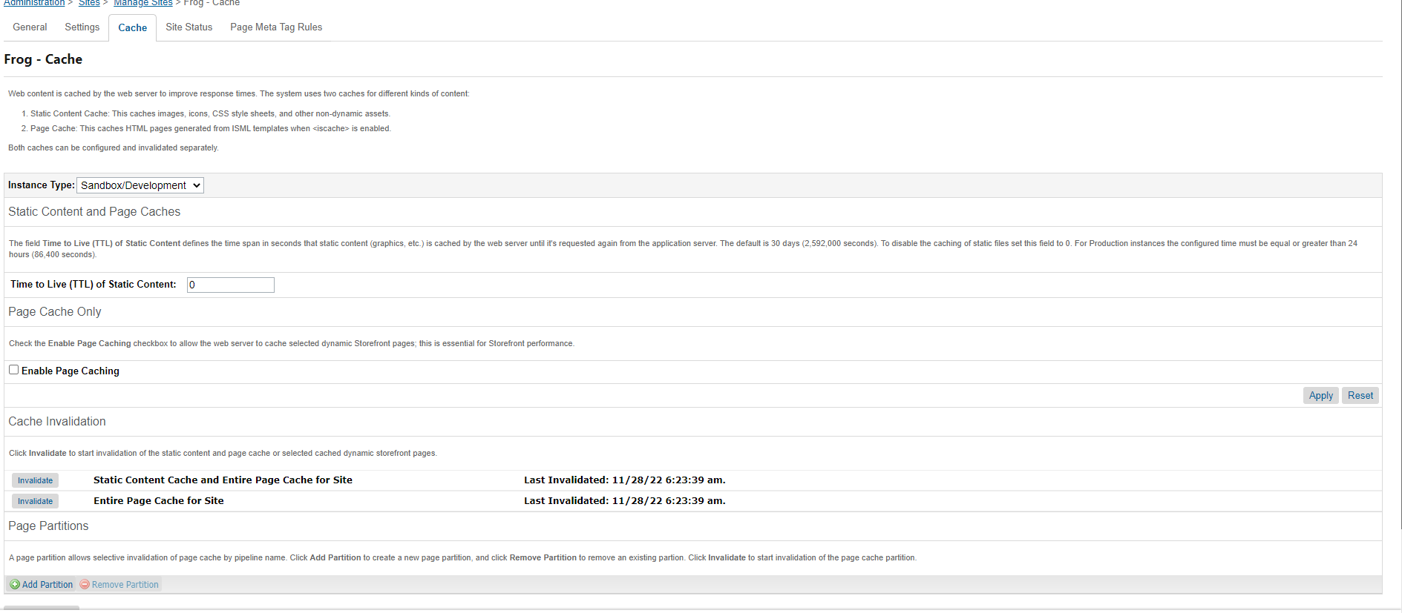

1. Use the site import & export to import the following data (create new storefront and master catalogs for your new site)

* Master Catalog
* Storefront Catalog



1. Use the module-specific Import & Export to import the following data (create a new inventory, price book for your new site)
   * Price Book
   * Inventory List





1. Import SiteGenesis customers into the new customer list which is assigned to your new site

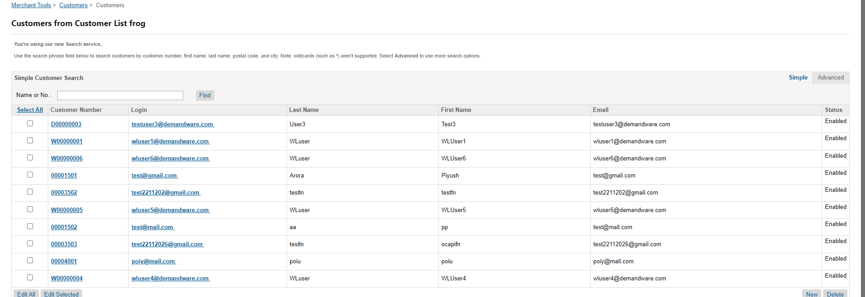

1. Create a static customer group and assign at least two customers to it
2. Create the following dynamic customer groups for your new site

* Group 1 Rule: Customers coming from Facebook
* Group 2 Rule: Birthday in next 30 days
* Group 3 Rule: US Customers

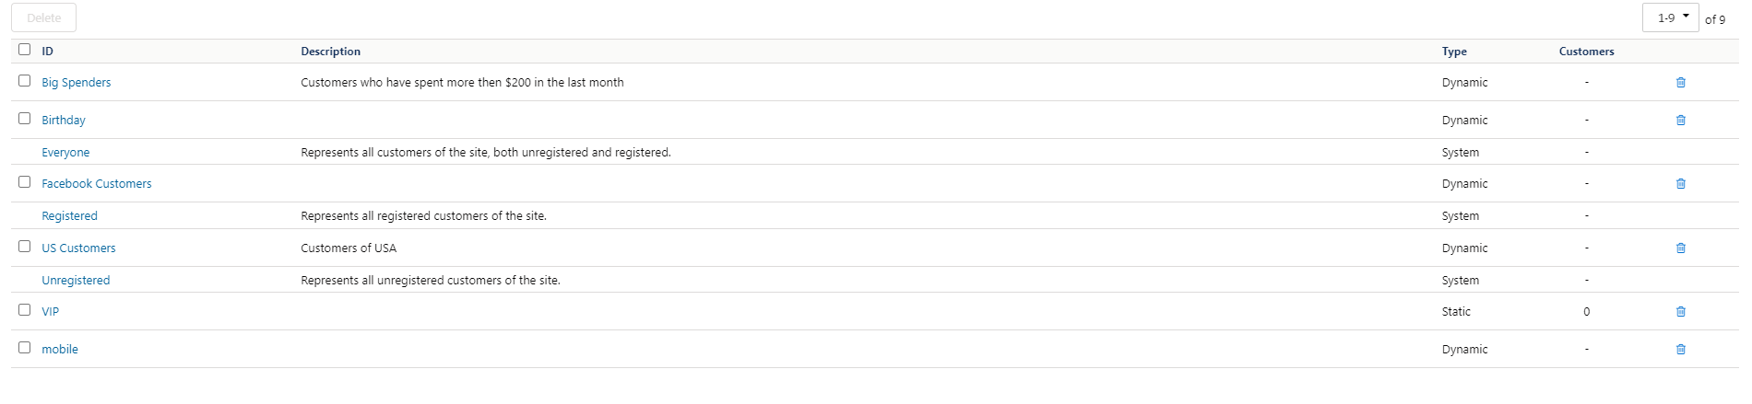

**Day-6**

1. Create a payment method “cash on delivery” and make it available for only two countries, price range should be $500 or above and only for registered customer group

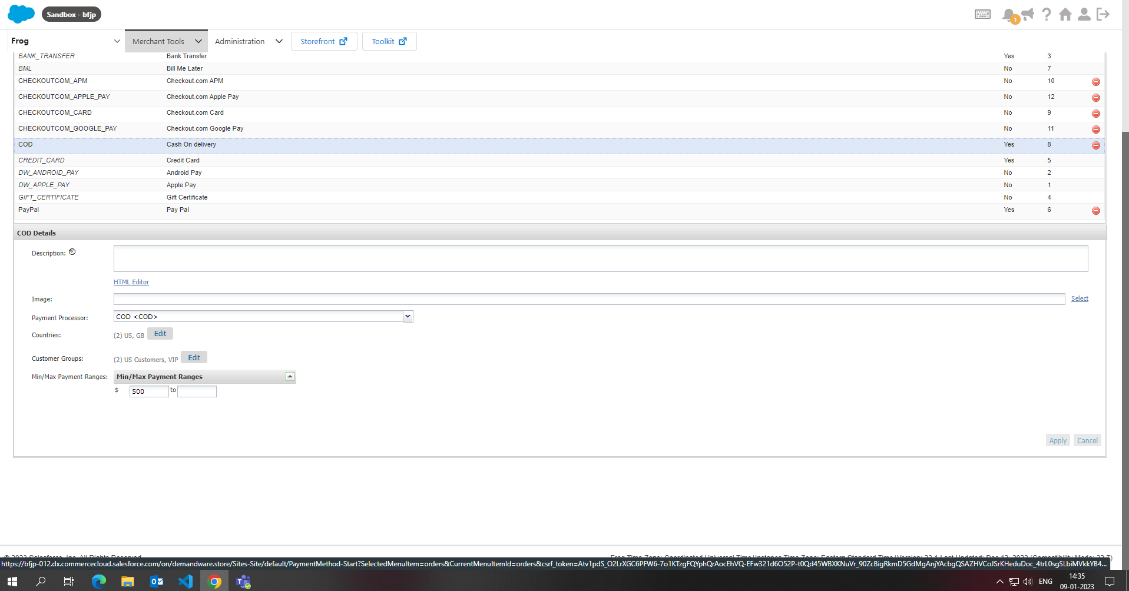

1. Create a new shipping method with currency as “USD” and make it available on the storefront only for electronics categories

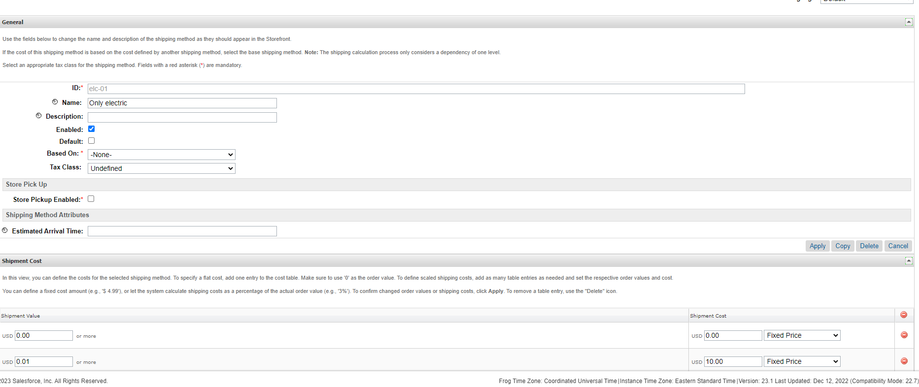

1. Define a custom tax class and configure tax rates for the US jurisdiction and this custom tax class combination

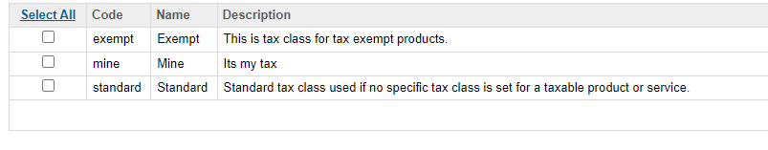

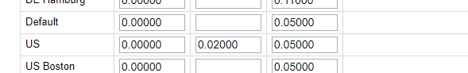

1. Use the newly created custom tax class for anyone product and check the changes on the storefront

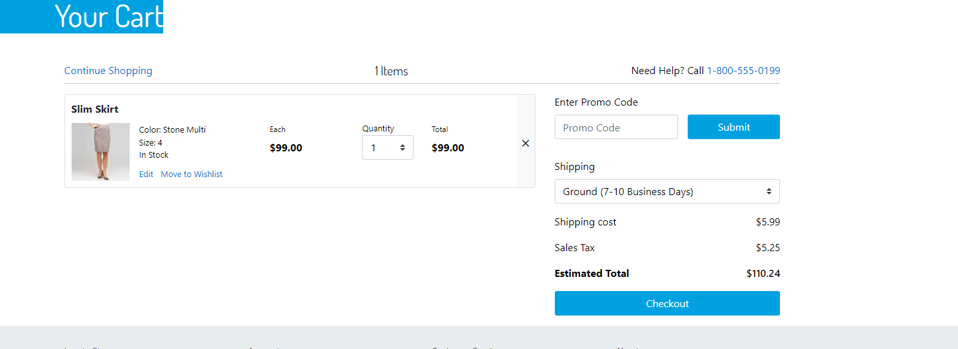

**Day-7**

1. Create a new content library for your new site using the import and export process
2. Assign your new site to the created shared library

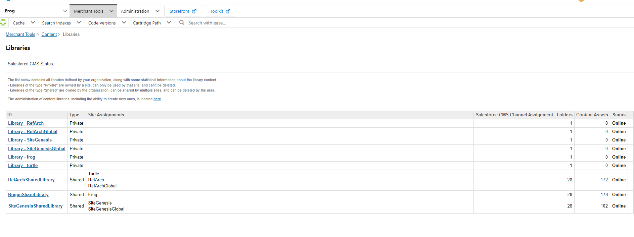

1. Create your own content asset with the [test data](https://www.lipsum.com/) and verify it on the storefront

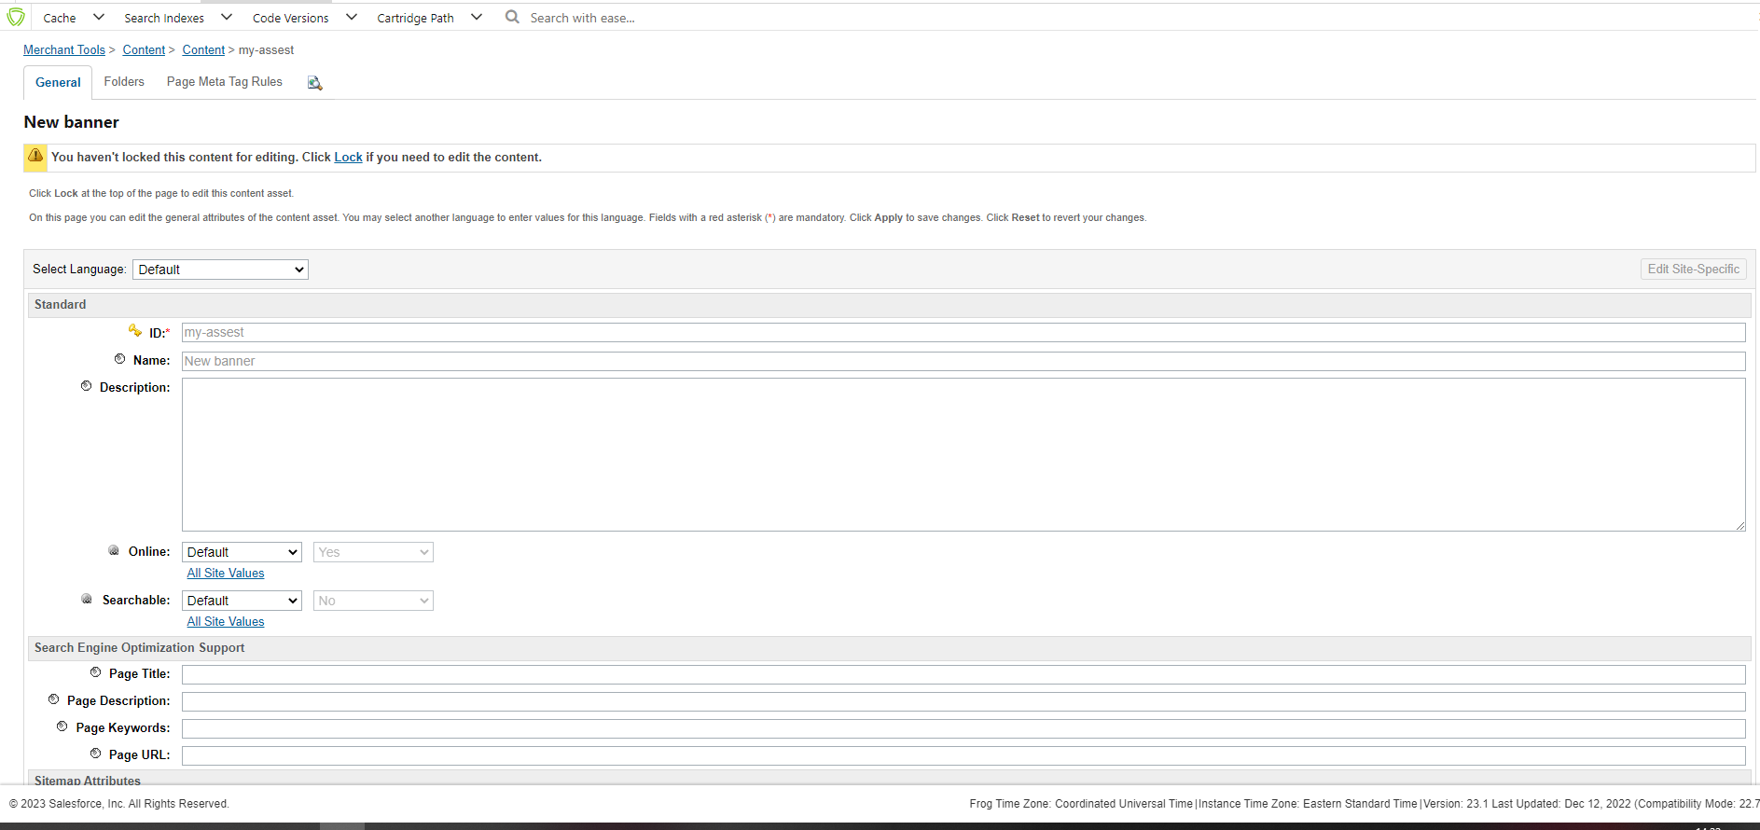

1. Use at least 3 content link functions in your new content asset to target the following resources
   1. An image to target a specific category
   2. An image to target a specific product
   3. An image to trigger the “shirts” keyword search

Note: Use the images available in the [demo_images](https://drive.google.com/open?id=1MyMtwrZtLOD9WaYWP1_sMy1JaMl5mCuW) folder

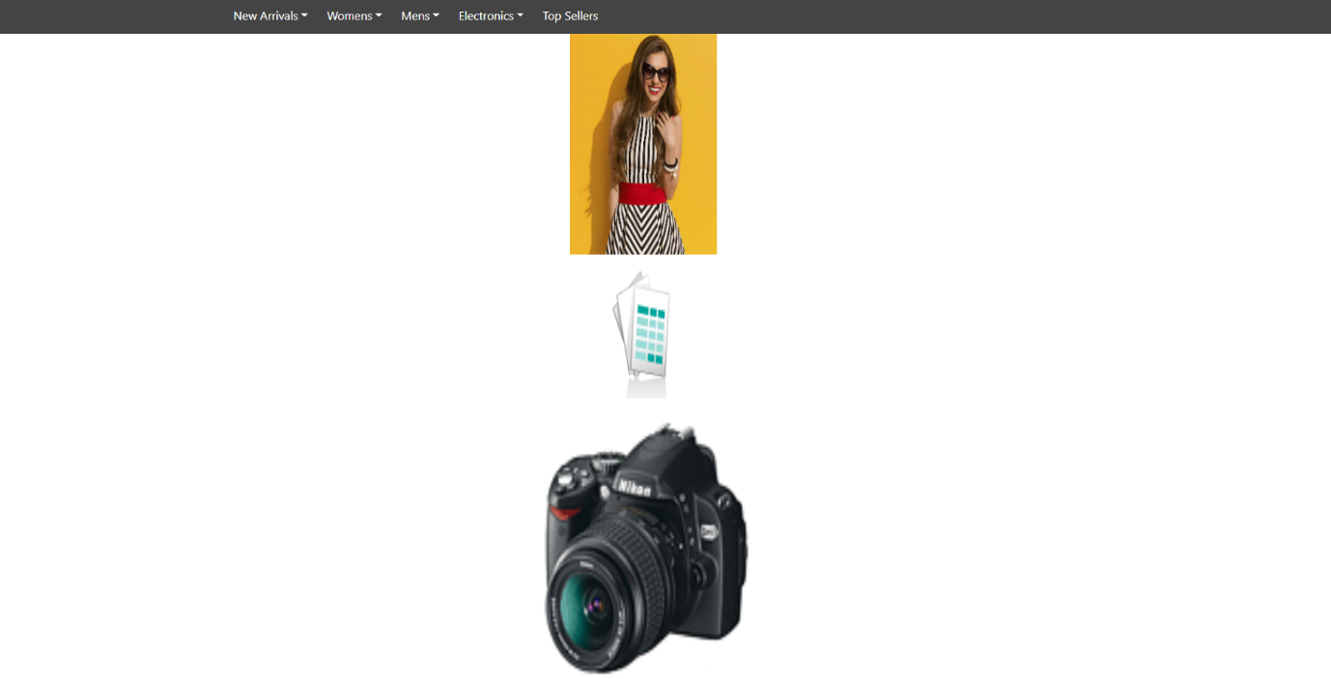

1. Export the SiteGenesis site Content Slots using the Import & Export section of the Online Marketing
2. Import the content slots of the SiteGenesis site into your new site using the Import & Export section of the Online Marketing Module

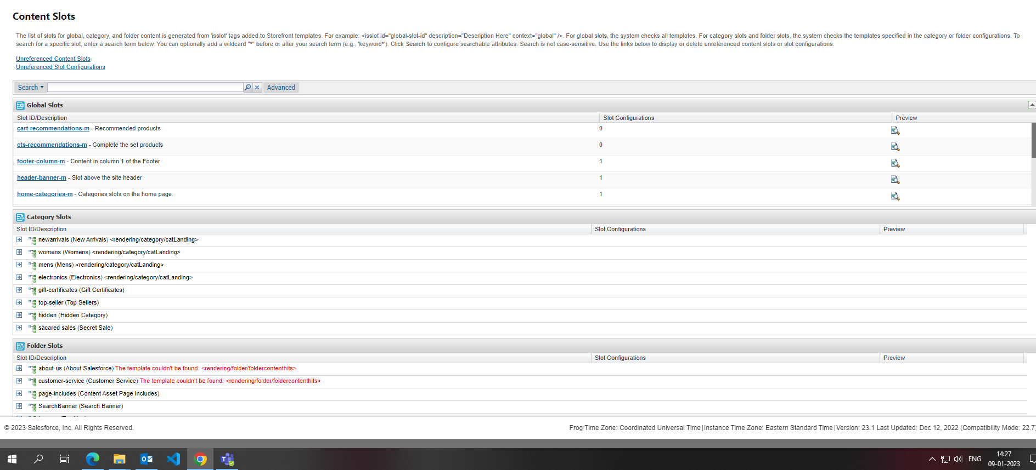

1. Create at least 4 new slot configurations (don’t delete the existing one and create in your new site) in the global slot “home-main” and configure the following content types
   1. A new slot configuration with the content type “Product”
   2. A new slot configuration with the content type “HTML”
   3. A new slot configuration with the content-type “Content Asset”
   4. A new slot configuration with the content type “category”

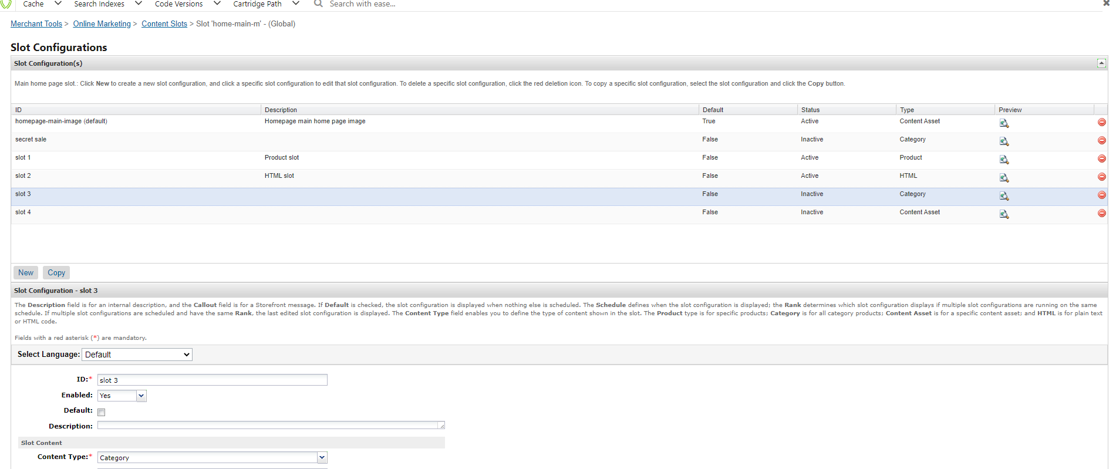

1. Create some slot configurations in the “home-main” slot to understand what is the use of default slot configuration and when does it render on the storefront

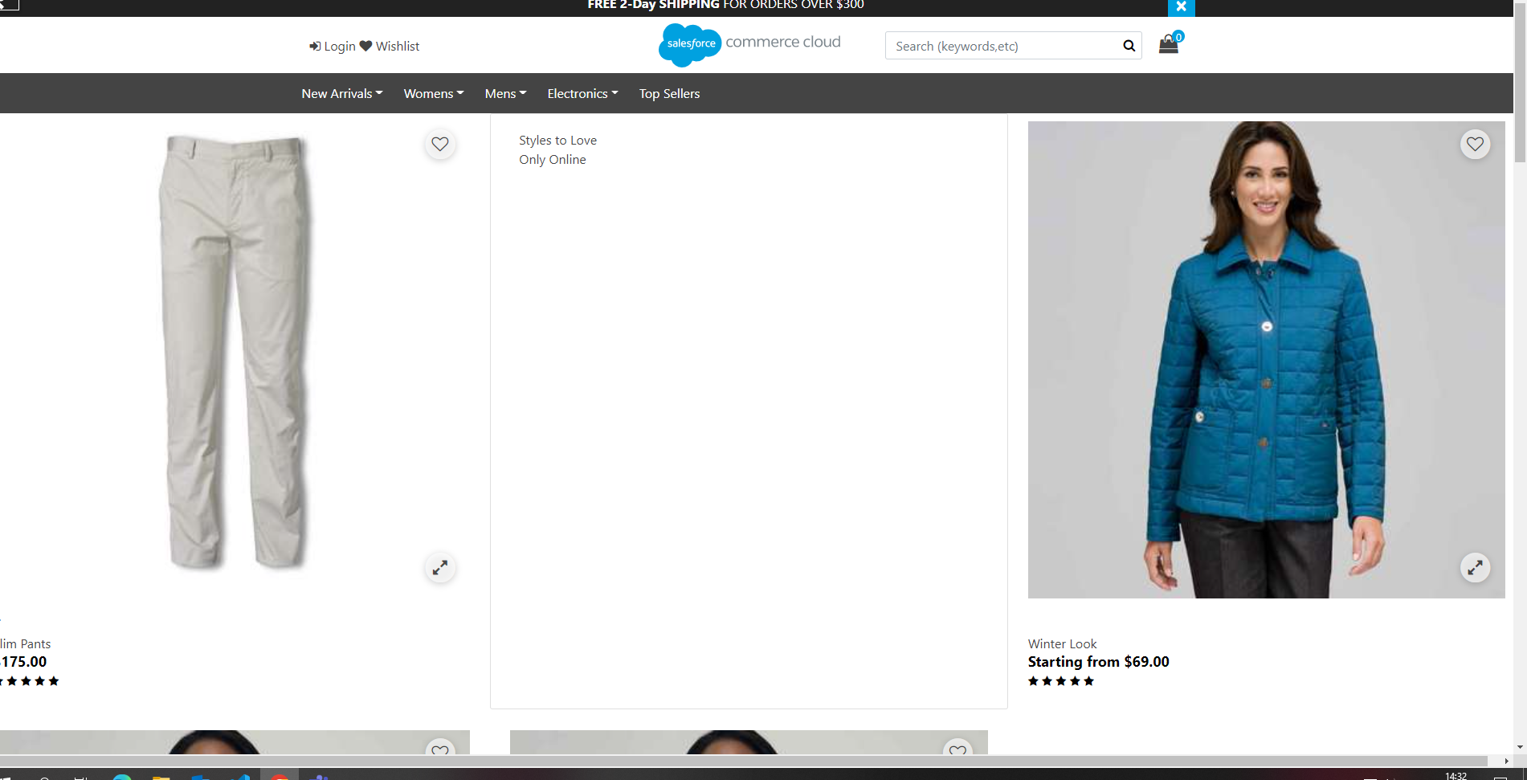

1. Create two slot configurations in the “home-main” slot with the below constraints
   1. the targeted customer group should be “unregistered” for both slot configurations.
   2. 1st slot configuration should run continuously
   3. 2nd slot configuration should run only on Thursday

Check the result on the storefront and use the rank to decide which slot configuration should be displayed on the storefront when there is a conflict

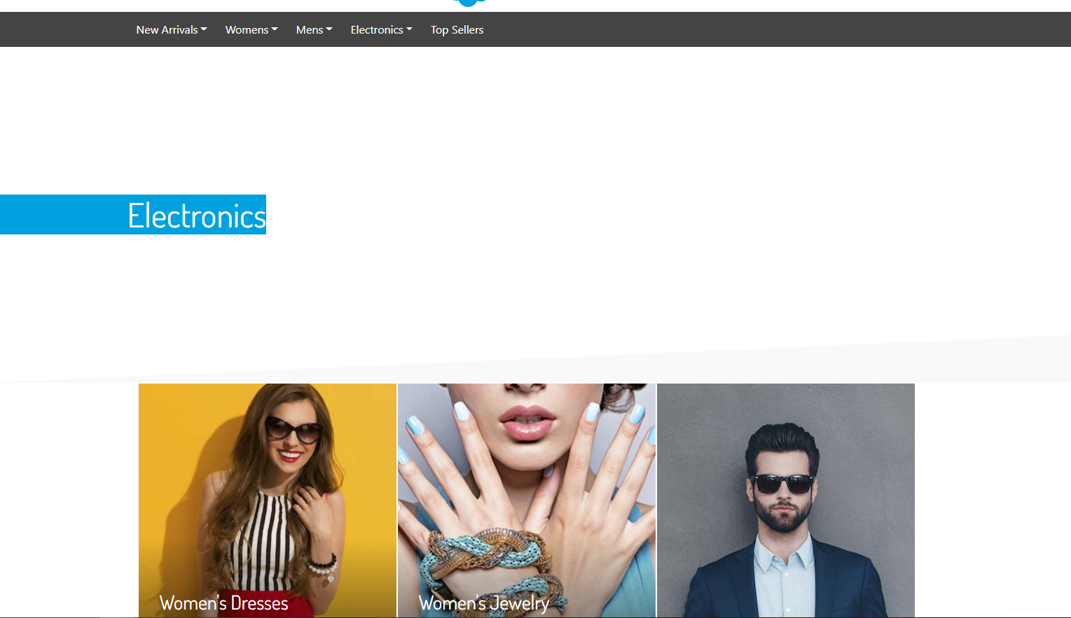

**Day-8&9**

1. Create a campaign with the below criteria
   1. Customer group: everyone
   2. Promotion: 10% discount on all orders
   3. During November Month

Hint: Create an order level promotion

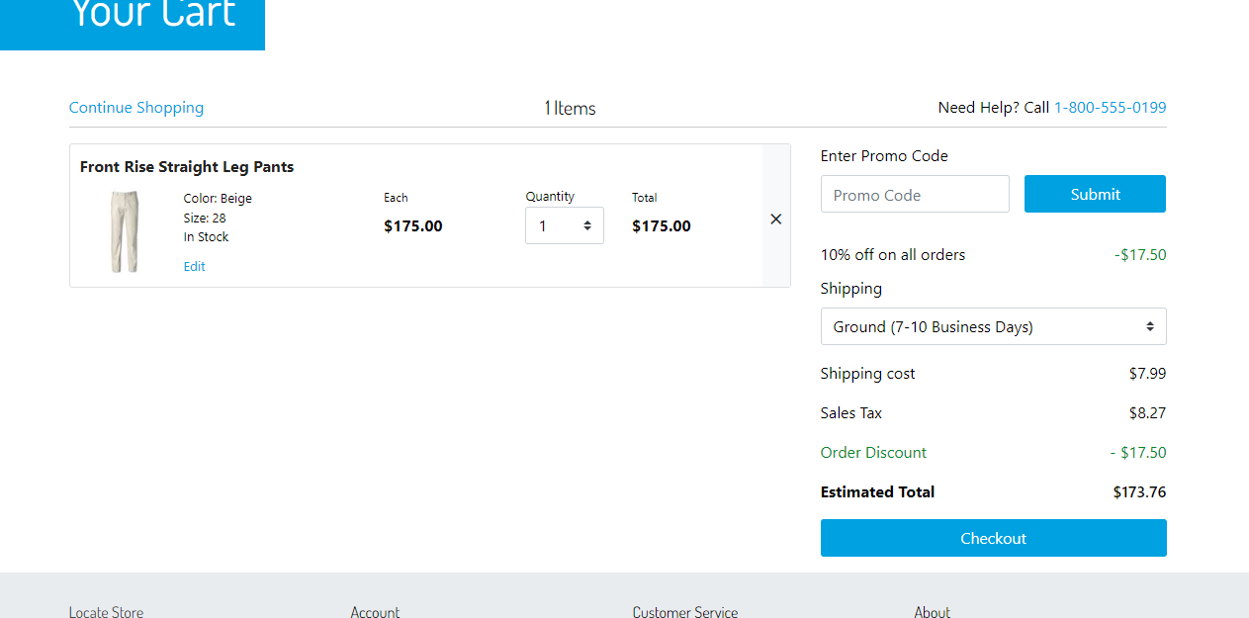

1. Create a campaign so that if a shopper purchases a “suit” (Mens → Clothing → Suits) then the shopper will get “Tie” (Mens → Accessories → Ties)  for free and make sure this particular tie “682875090845” got excluded from all the promotions

Hint: Use Buy X and GET Y discount type

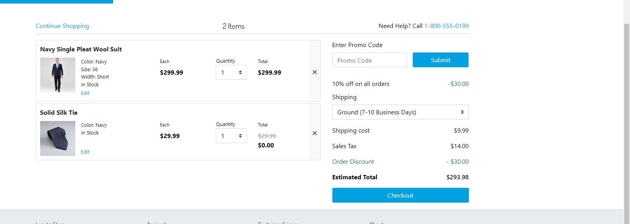

1. Create a campaign so that visitors click in a specific Newsletter email get free shipping for orders above $100.

Hint: use source code as a qualifier and create a shipping level promotion

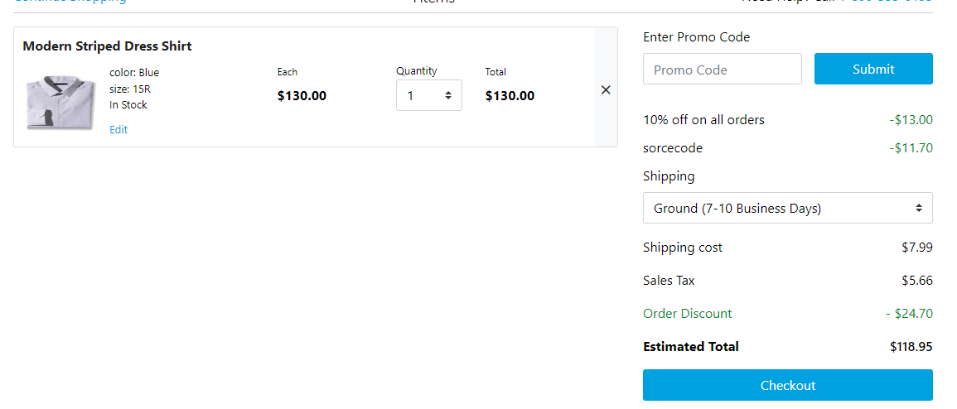

1. Create a campaign so that the registered shoppers with the below coupon code should be able to get a 10% discount on the televisions category and all its subcategories
   1. Coupon code: TEL10

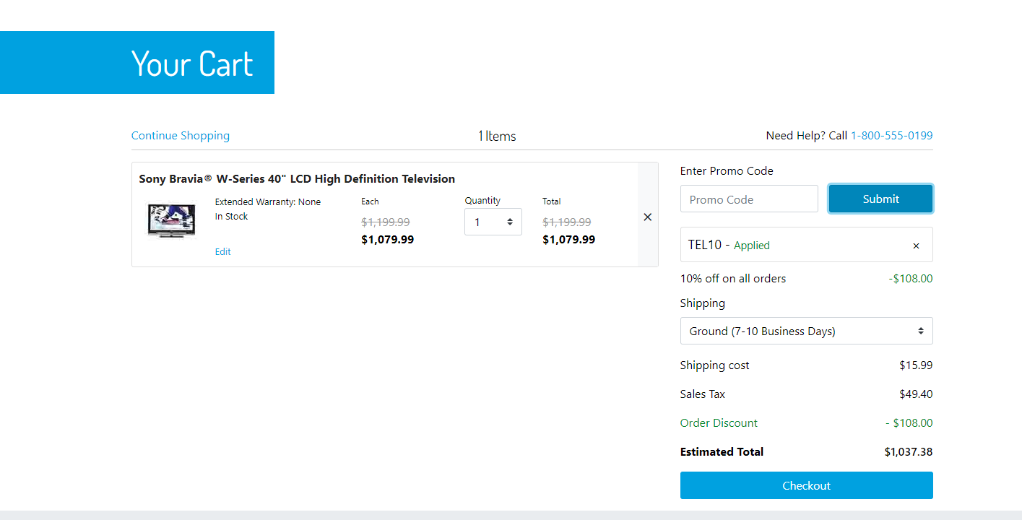

1. Create a campaign so that all the mobile users should be able to get a 20% discount on the entire order and free shipping and let a shopper know about this campaign by showing a banner on the homepage and make sure that it can’t be clubbed with any other promotion

Hint: Create two promotions, one content slot and one dynamic customer group

1. Order level promotion

2. Shipping level Promotion

3. Create a content slot configuration (use ‘home-main’ slot)

3. Create a Dynamic customer to segregate mobile users

4. Link experiences (promotions, content slot) with the qualifier (customer group) in a campaign

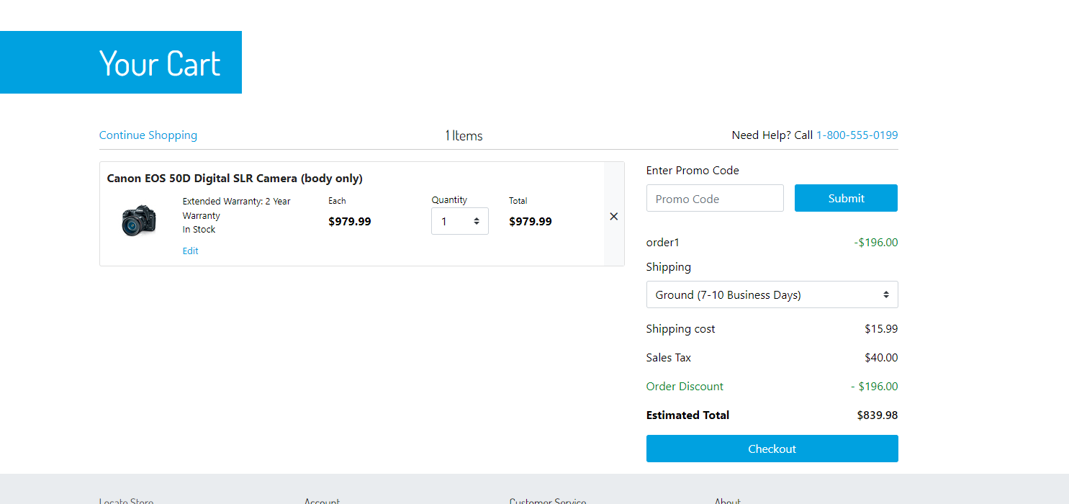

1. Create a campaign so that a registered user should be able to access a secret sale category by clicking on a banner on the home page. (Note: The secret sale category should not be displayed in the storefront navigation)

Hint: Create a category “secret sale” and assign some products to it and create a banner on the home page to target this specific category. (Make sure the banner is only shown to registered customers)

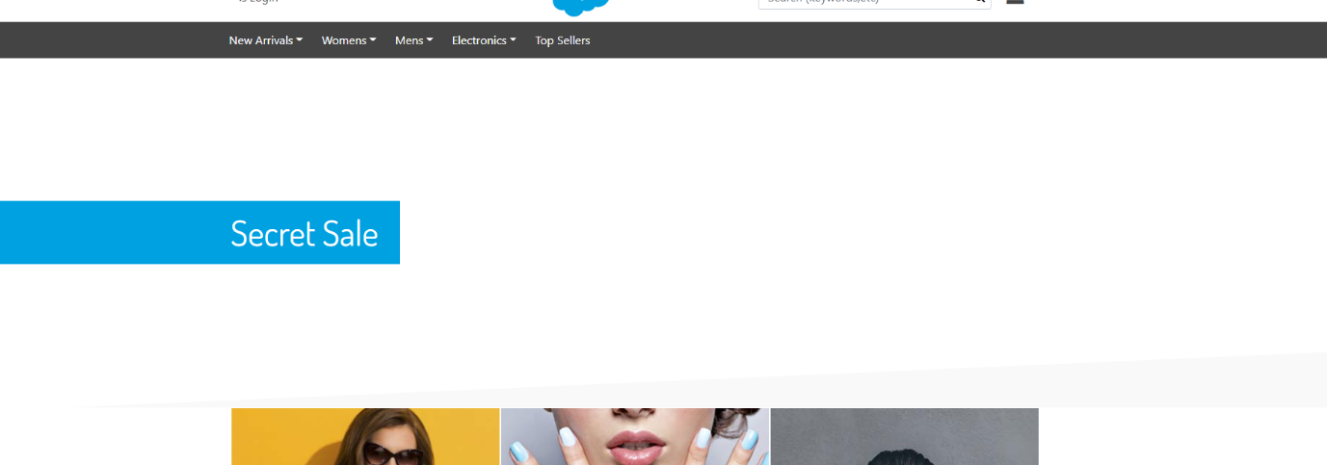

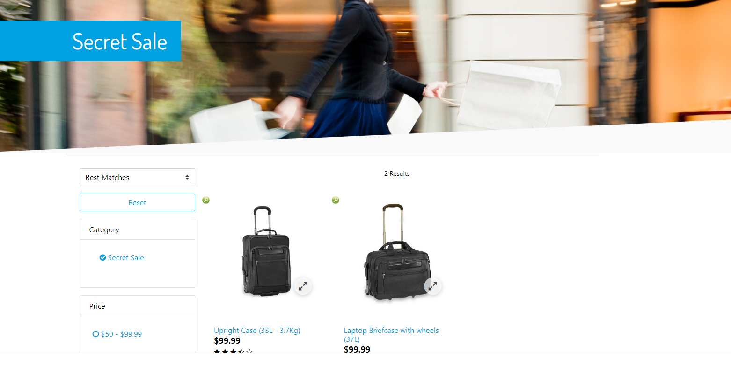

1. Create a campaign so that the big spenders should be able to see “price high to low” as the default (implicit) sorting rule for the women’s tops category (Womens → Clothing → Tops) and others should be able to see the “best-matches” sorting rule as the default sorting rule

Hint: Leverage the “Big Spenders” dynamic customer group which is there in sitegenesis site

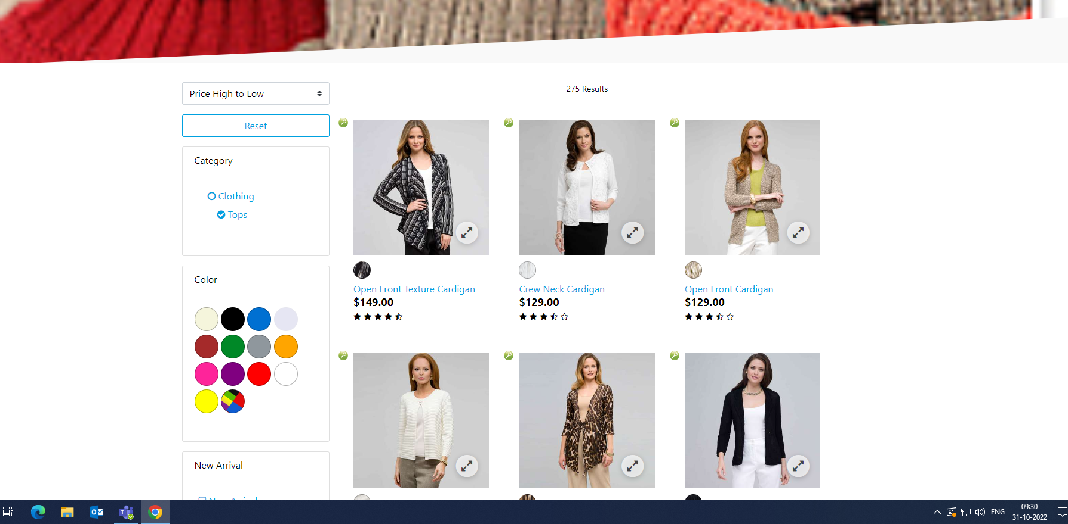

8. Create two product level promotions (you can use any discount type) on the “Mens → Clothing → Pants” and make sure the both are mutually exclusive and available for registered users.

Hint: Use class level exclusivity

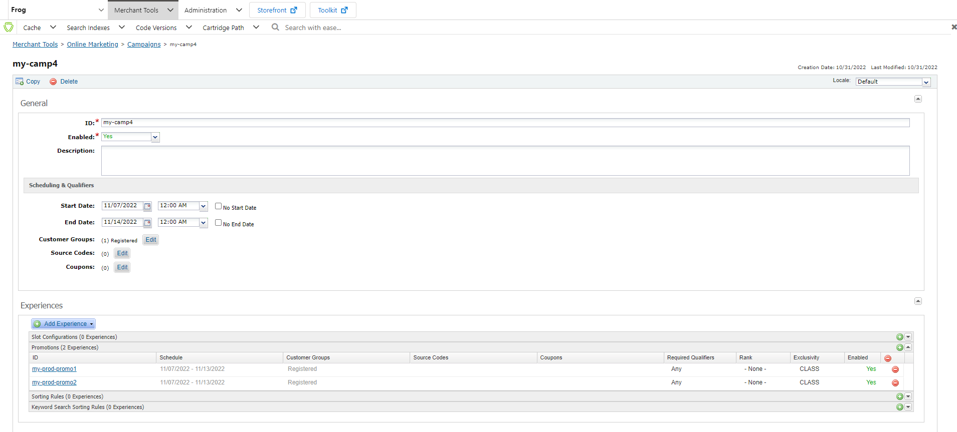

**Day-10**

1. Setup SFRA project by following the steps mentioned in the [SFRA project setup document](https://docs.google.com/document/u/0/d/1_AHDHXL11VzSUSUku-2lTaBkv2bg2iMs/edit)

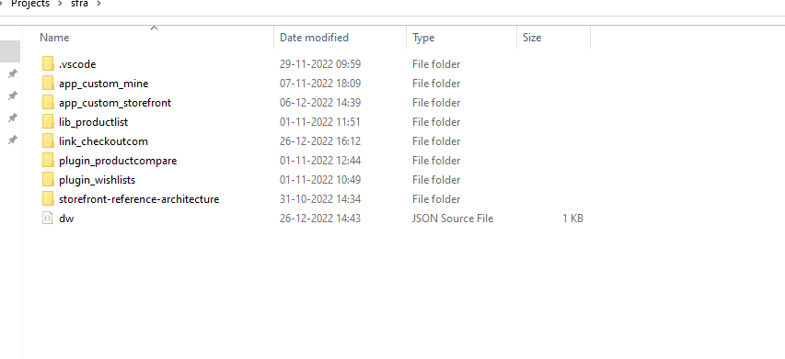

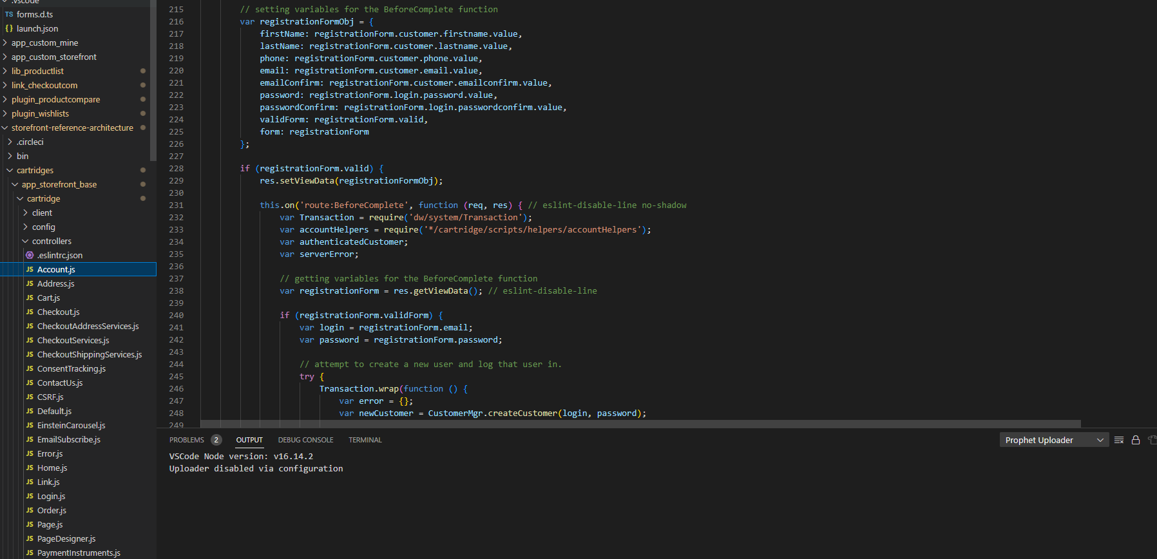

**Day-11&12&13**

1. Create your own site based on the RefArch site

**Hint**: Export the RefArch site from the site import & export section and change the site id and import it (follow this [process](https://docs.google.com/document/u/0/d/1fao0f6YYxUkTq1RI5iI4jzMl9LTrKd3L/edit))

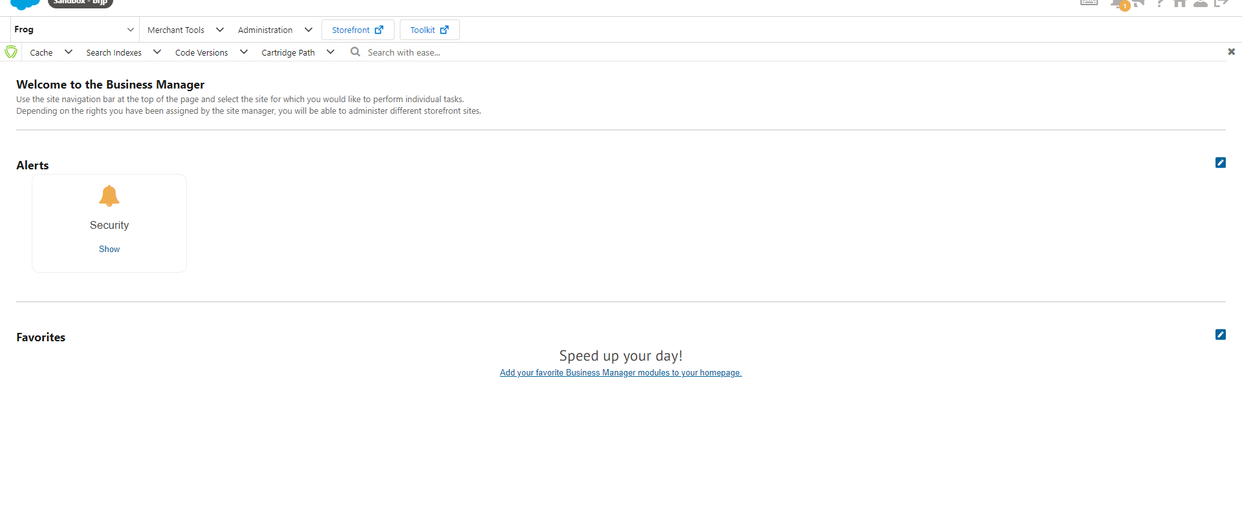

1. Create a new code version

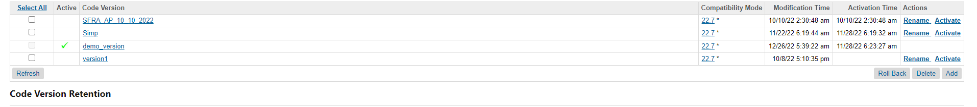

1. Setup the project in your local system by following the below steps

* Create a folder structure (projects → sfrademo)
* projects
* sfrademo
* Clone the [Storefront Reference Architecture repository](https://github.com/SalesforceCommerceCloud/storefront-reference-architecture) from the GitHub
* Build the project
* Open the “sfrademo” folder as a visual studio code workspace
* Upload the cartridges to your new code version

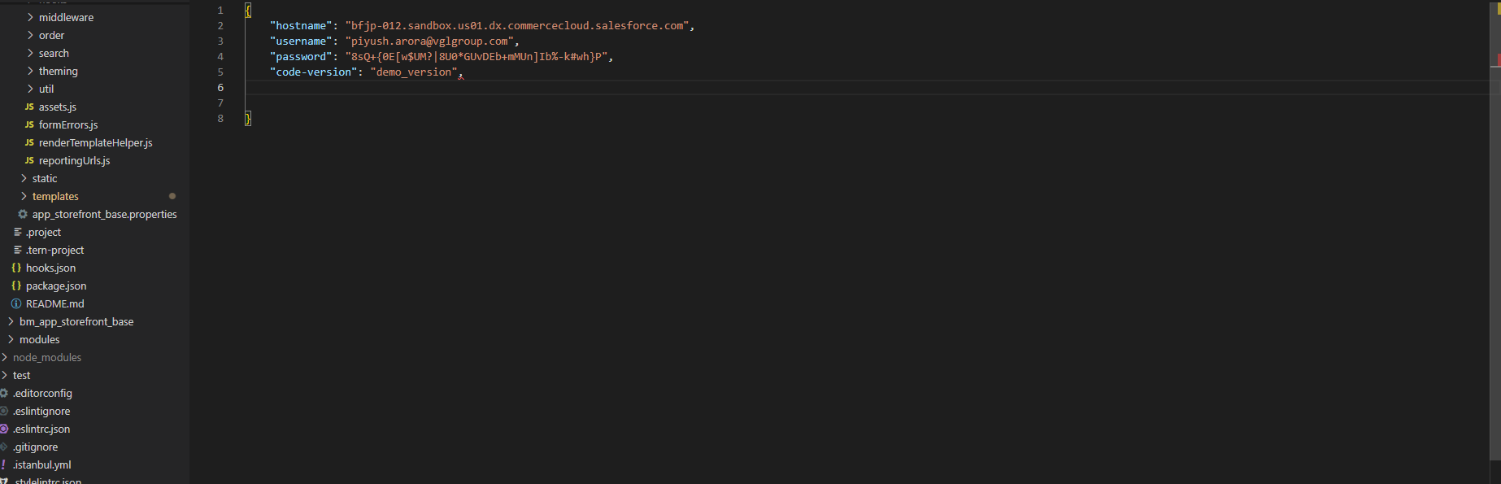

1. Integrate [plugin_wishlists](https://github.com/SalesforceCommerceCloud/plugin_wishlists) cartridge to your site (your custom site) by following the below steps

* Clone this repository into the “sfrademo” folder
* Build the project
* Clone the lib_productlist repository into the “sfrademo” folder
* Install dependencies for lib_productlist project (repository)
* Use Visual Studio Code to upload all these cartridges to your new code version
* Register these cartridges for your new site
* Activate your new code version to see changes on the storefront
* **Hint**: Get the plugin_wishlists cartridge from the Salesforce Commerce Cloud GitHub account and follow the steps mentioned in the readme file of that repository
* **Note**: This plugin depends on the lib_productlist cartridge

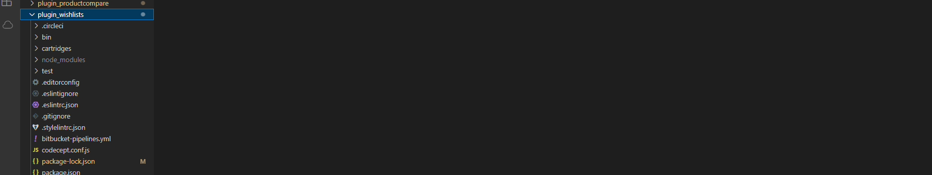

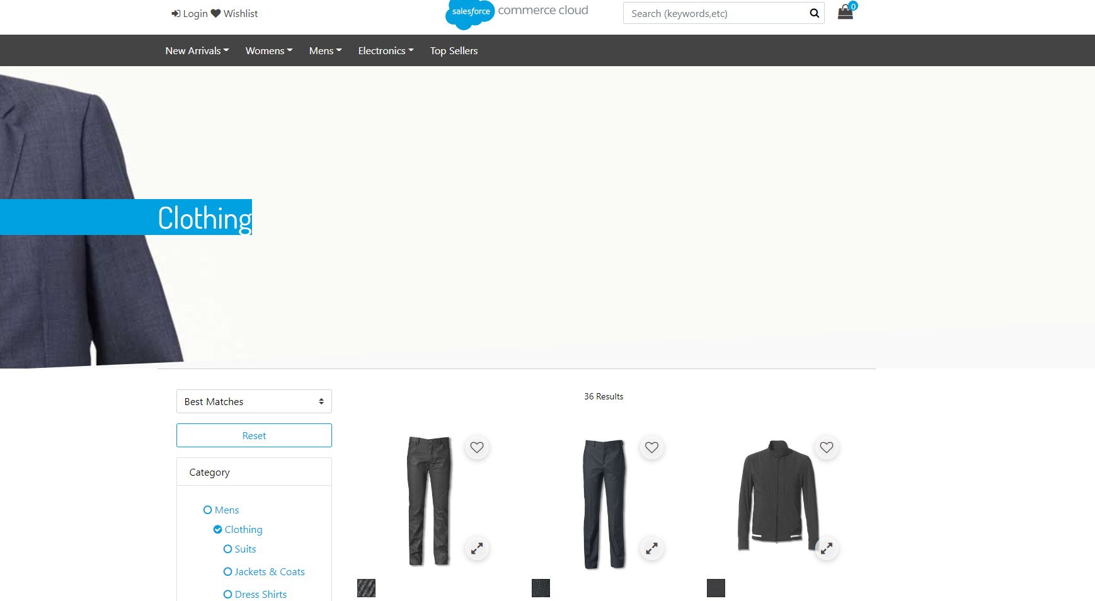

1. Create a custom cartridge “app_custom_storefront” in the “sfrademo” folder and upload it to the server

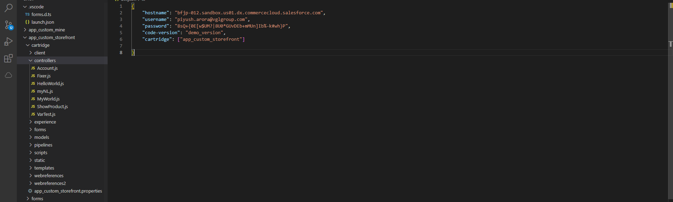

1. Create a Controller in the app_custom_storefront cartridge with a route to show a hello world message on the storefront

**Note**: Make sure the code version is active and you have registered this cartridge for your site

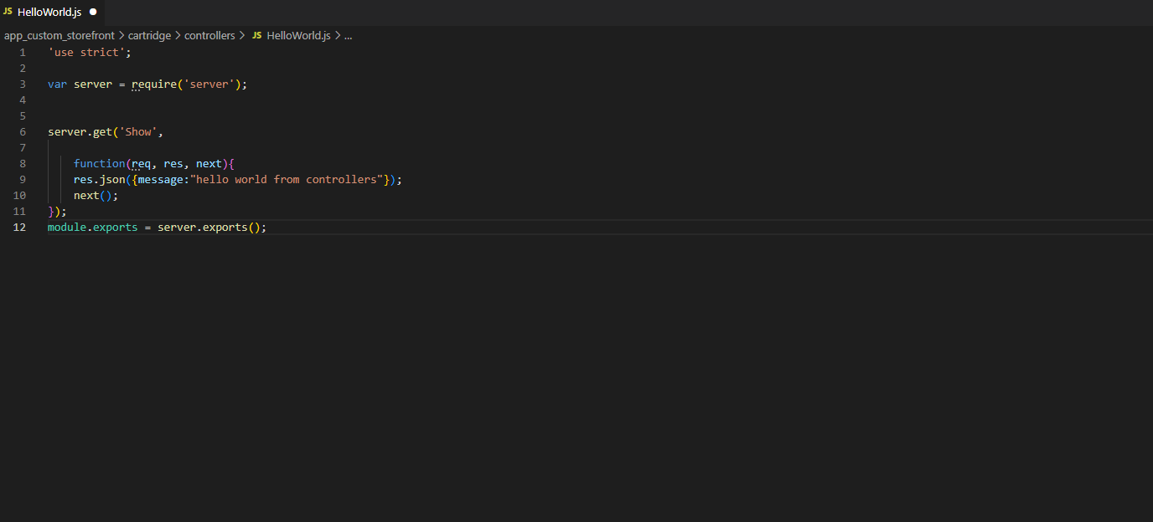

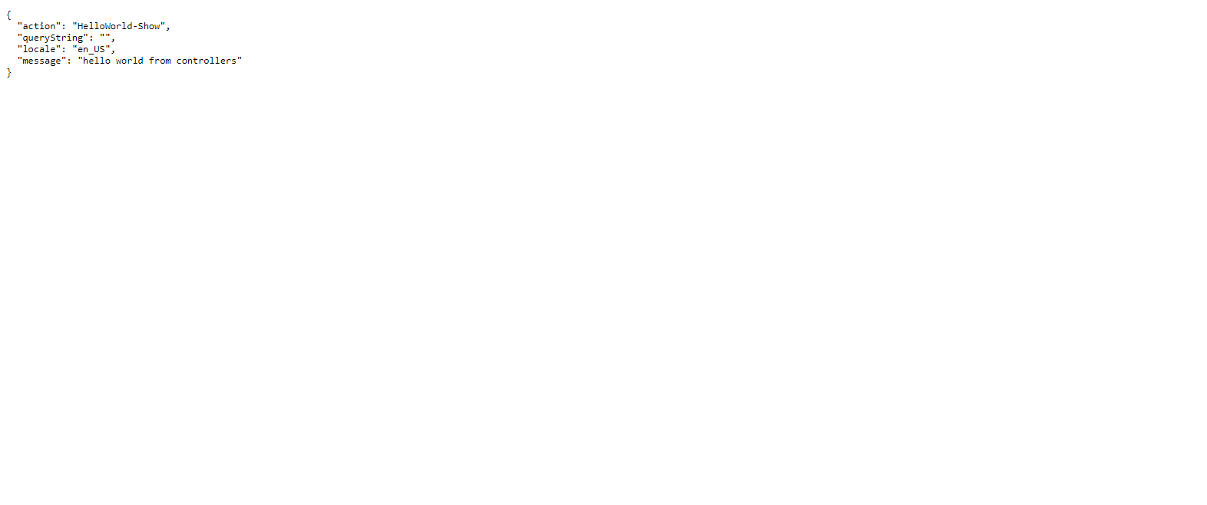

**Day-13**

1. Create a Custom cartridge using Prophet Debugger

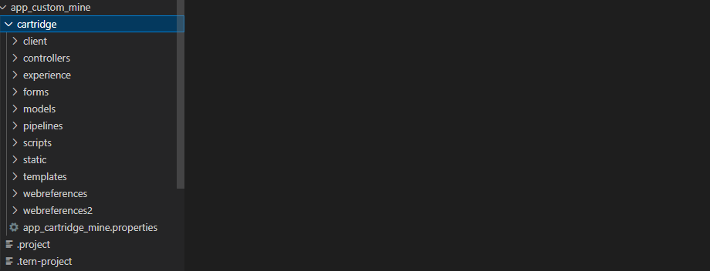

1. Register this custom cartridge for your site (cartridge path)



1. Create a controller and define “Start”, and “Show” routes, and make sure that the main function in both routes should render a template or JSON

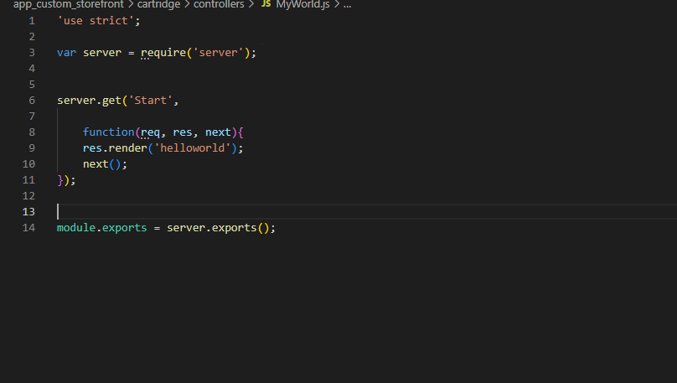

1. Create a script in your custom cartridge and define some middleware functions (ex: m1, m2, m3, m4…..)  and expose those functions to reuse

Hint: create it in the scripts folder and use res.print() function to print some message

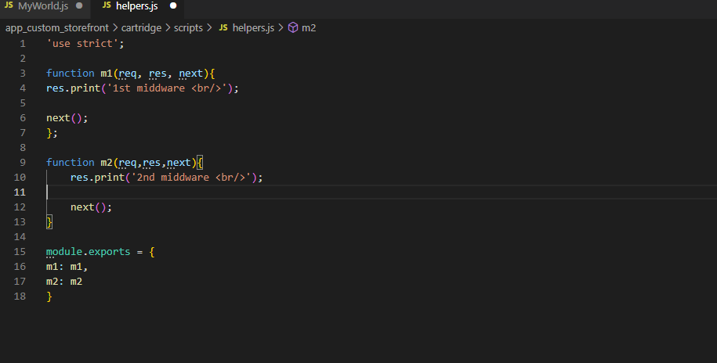

1. Require the script in your controller and add those middleware functions to your routes and check the result on the storefront

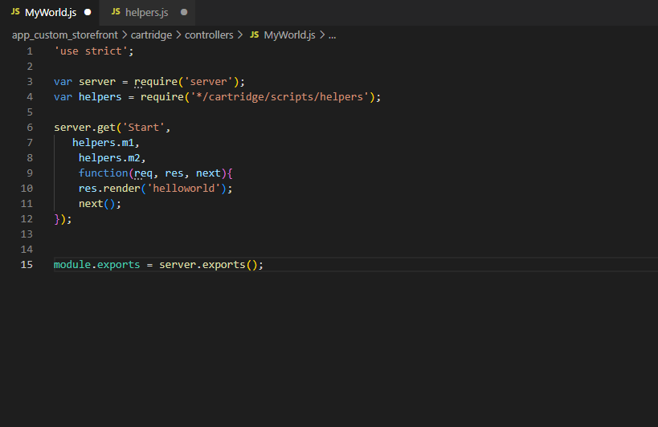

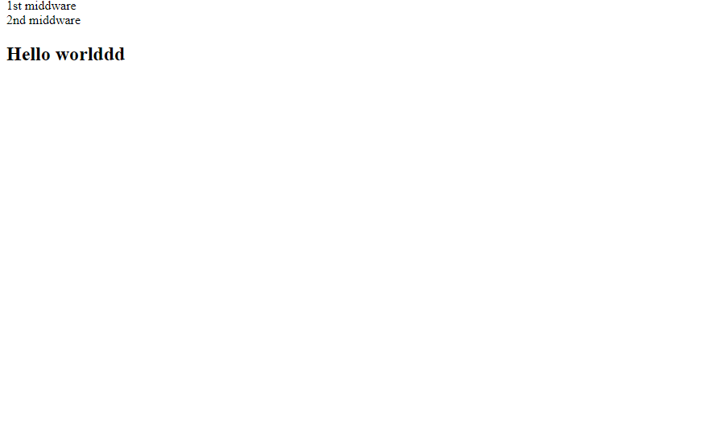

1. Set some data in your middleware functions by using res.getViewData() and res.setViewData() functions

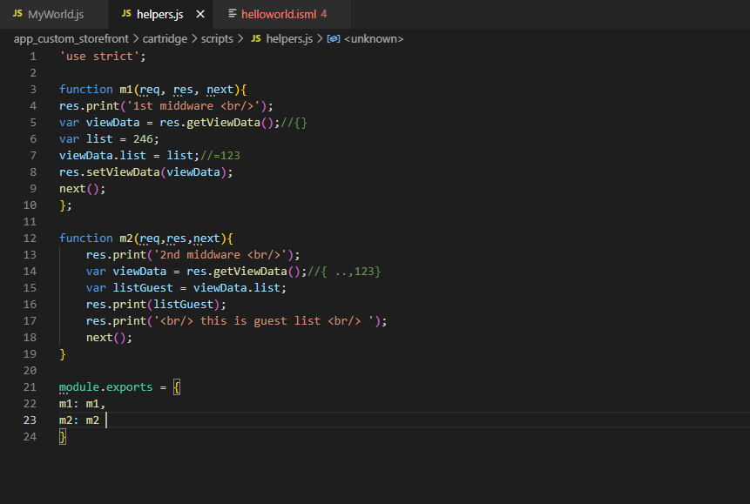

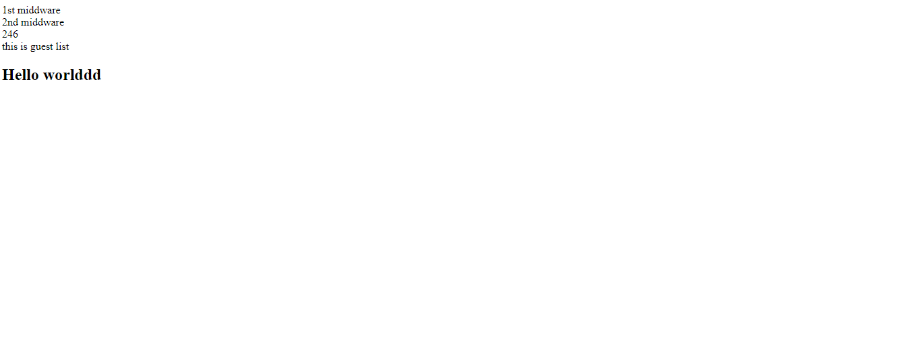

1. Create one more custom cartridge to extend the controller created above
2. Extend the “Start” route

Hint: Use the server.prepend and server.append methods

1. Replace the Show route

Hint: Use the server.replace method

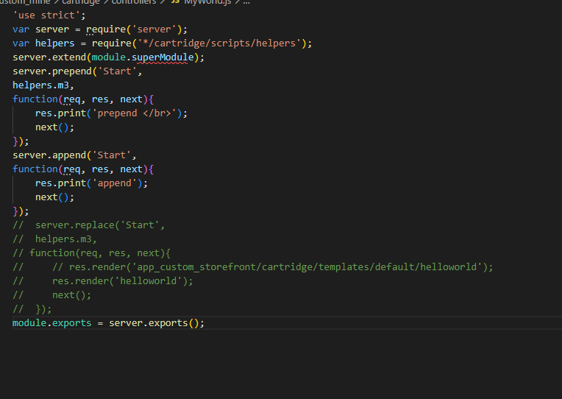

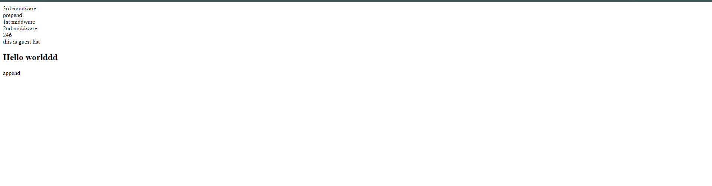

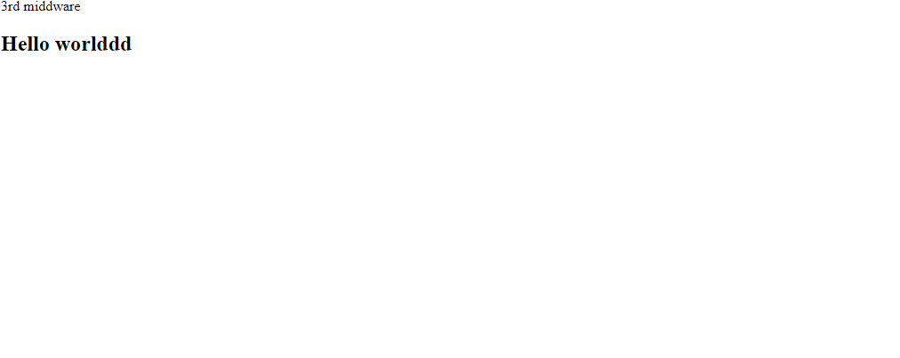

**Day-14&15**

1. Create a controller “VarTest.js” and render a template with some data and
   1. Make sure that you define at least two variables using isset tag with different scopes in the template
   2. Present all that data, variables using ISML expressions

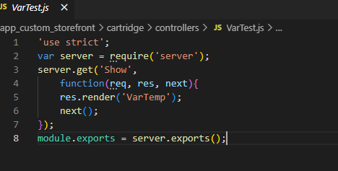

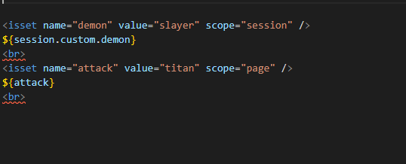

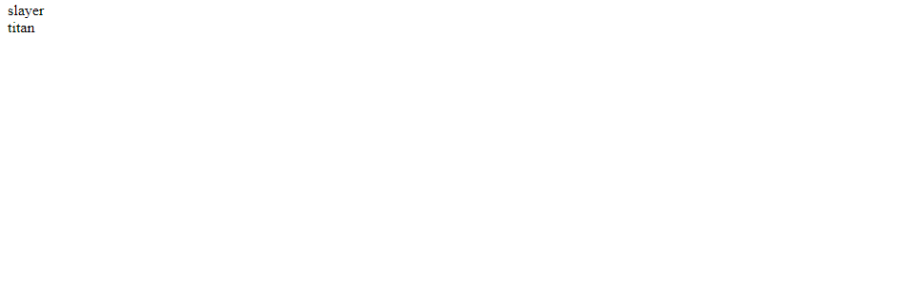

1. Print your site id and number of registered customers for your site using ISML expressions (you can use the above-created template)

Hint: Use dw.system.Site, dw.customer.CustomerMgr APIs

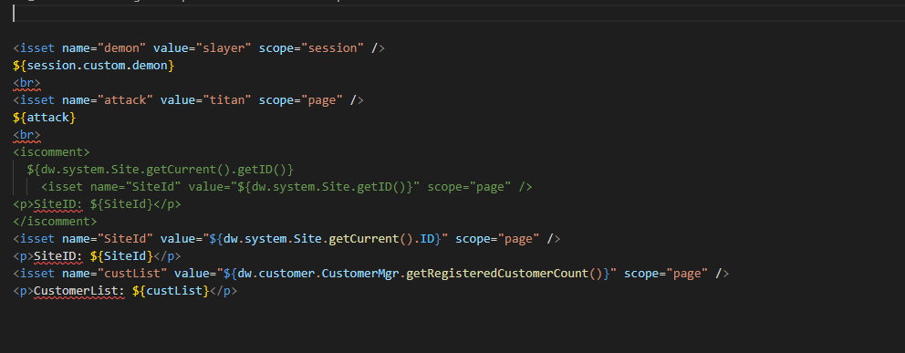

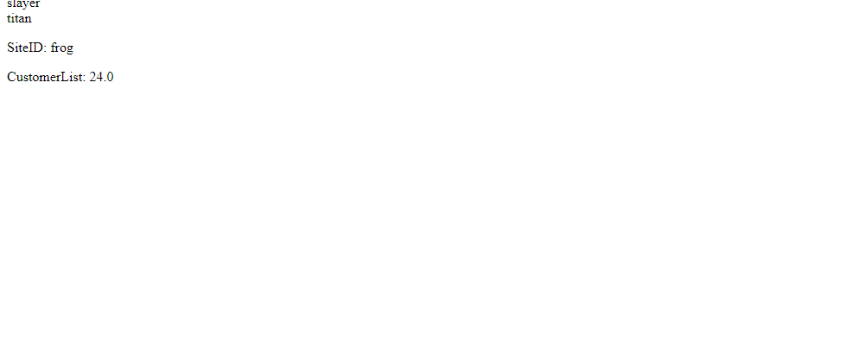

1. Create a ShowProduct.js controller and the following templates. The controller route should take the HTTP parameter “pid” as input (use req.querysting) and use that to get the product object (use product.js file present in factories directory).
   1. Render productfound.isml with product data (name, id and description) if the product is found
   2. Render productnotfound.isml to display “product with this {id} is not available”

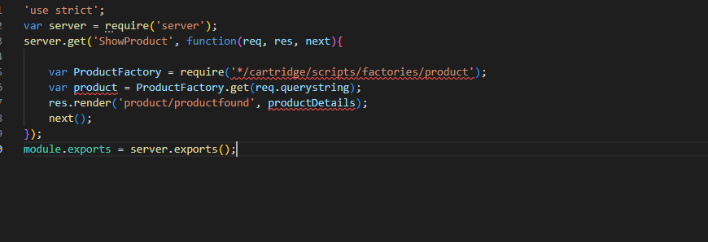

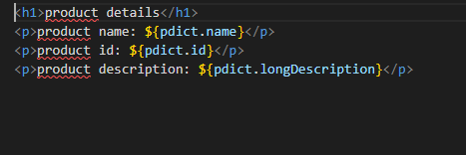

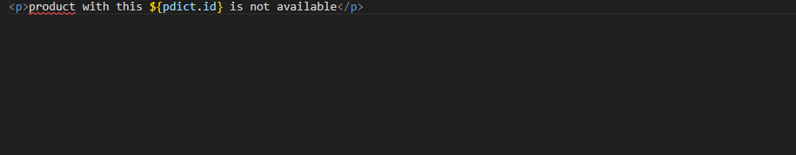

1. Create your own custom tag

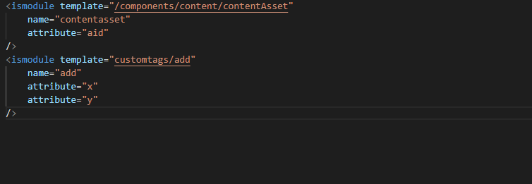



1. Create your own decorator template and use it for the homepage.isml and productfound.isml

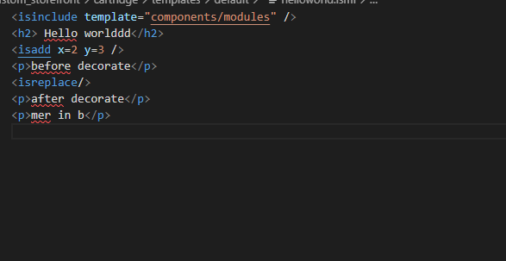

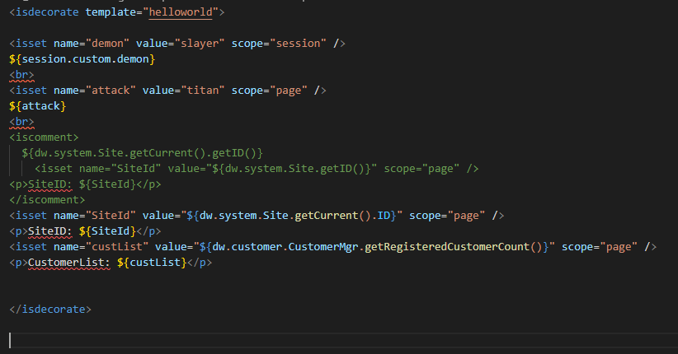

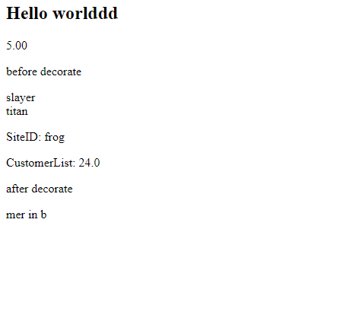

1. Create a custom attribute isTrending for Product system object type and provide value to that attribute for some products

Hint:

● Use BM (Administration → Site Development → System Object Types →Product → Attribute Definitions Tab) to create this attribute and make sure it is a boolean type attribute

● Assign the value to this attribute for all the products in the televisions category(or any other products also fine)

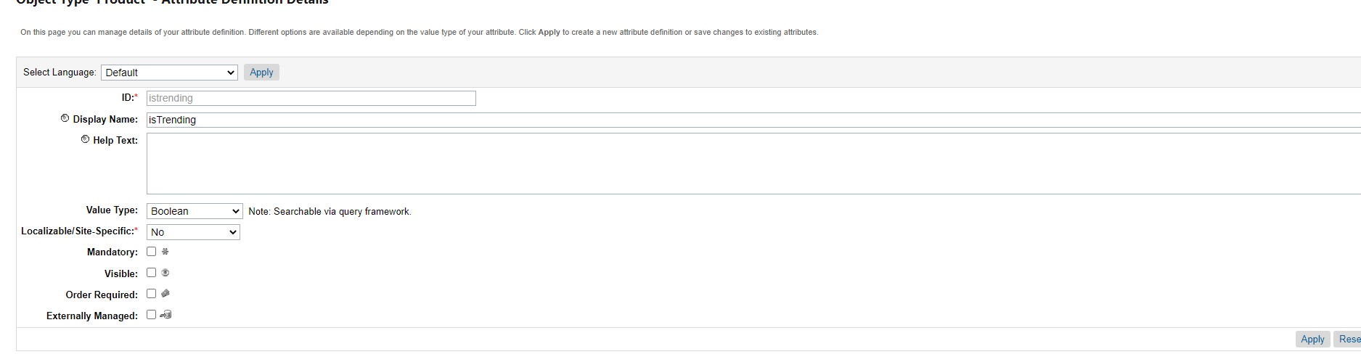

1. Extend the product model to send this “isTrending” attribute data to the frontend (templates)

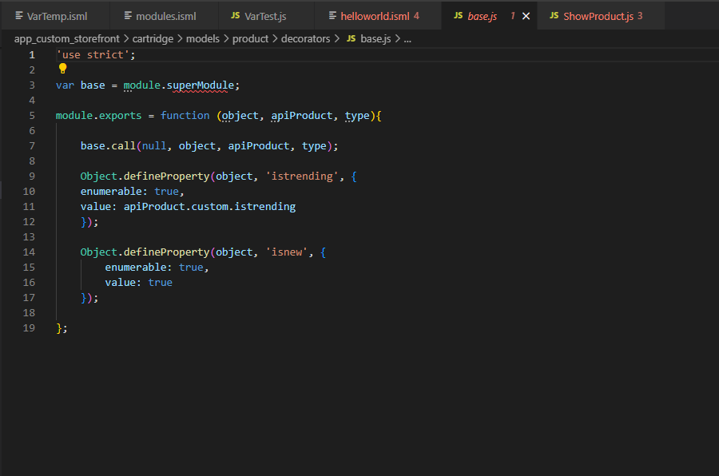

1. Present “isTrending” value to the shopper by rendering productfound.isml file

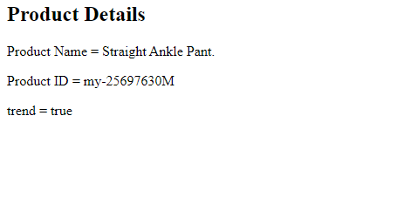

**Day-16**

Create a form using the forms framework to implementNewsletter Subscription functionality

a. Make sure you are managing all the hardcoded strings through Resource bundles (properties files)

Hint:

● Use Resource.msg, Resource.msgf APIs to access properties in your

code (ISML, Controllers, scripts, view models)

● Use keys from forms.properties file in the form metadata files (XML

file)

b. Create a custom log category “newsletter” in the BM

c. Create a log file in your code for the above-created custom log category and make sure that the log file prefix should be “NLSubscription”

d. Use the log file for logging while implementing the Newsletter Subscription functionality

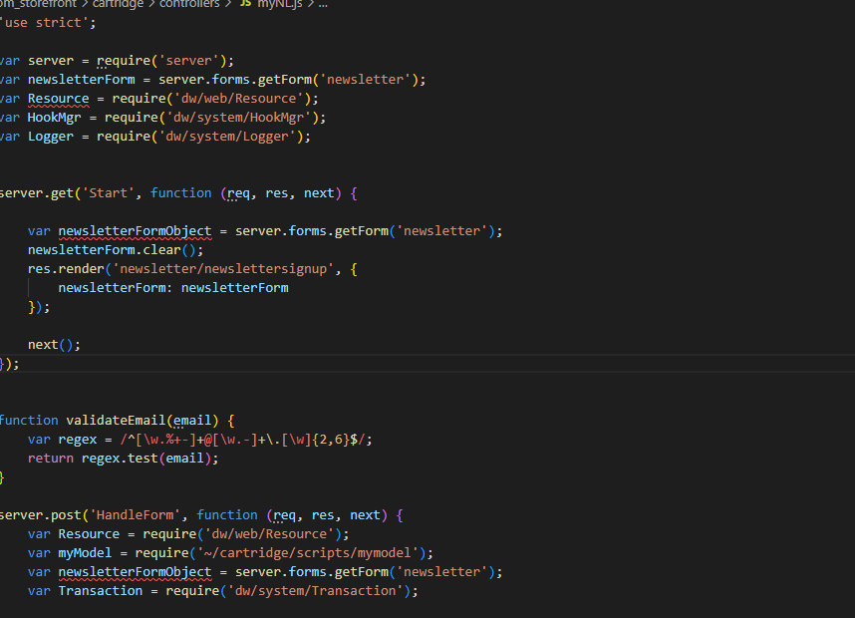

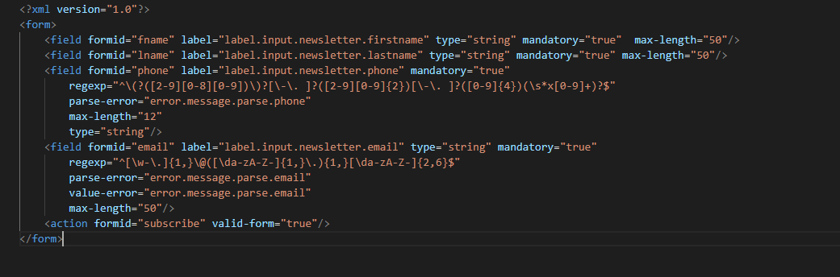

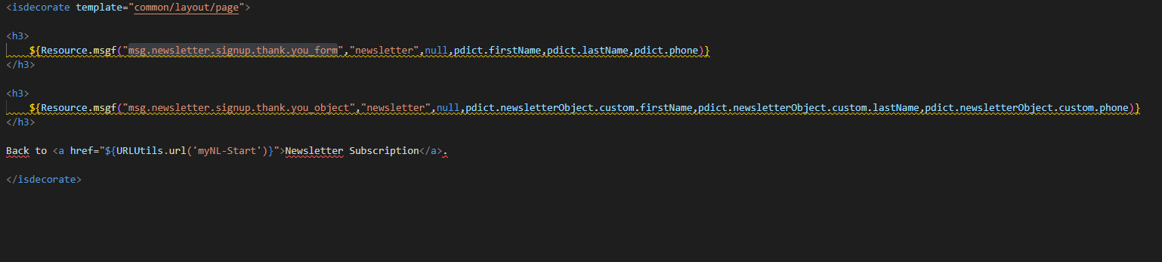

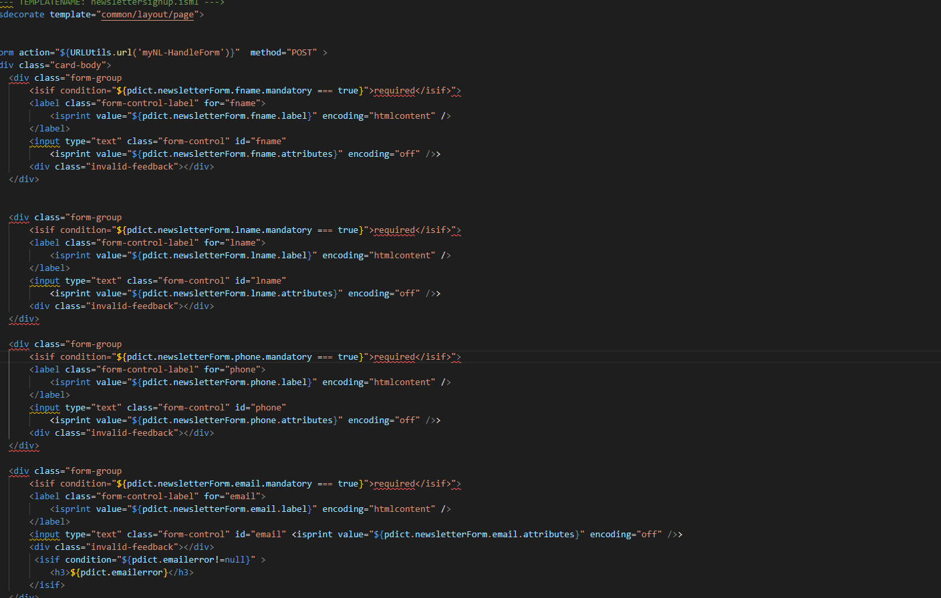

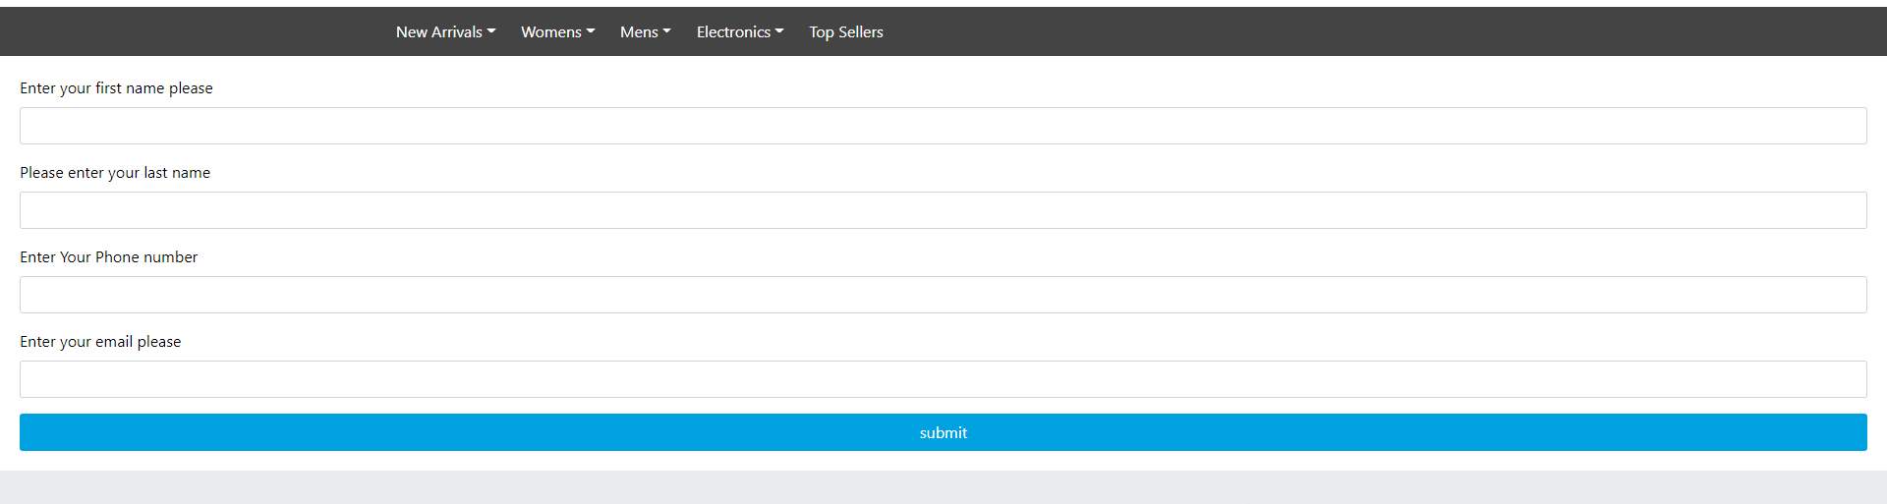

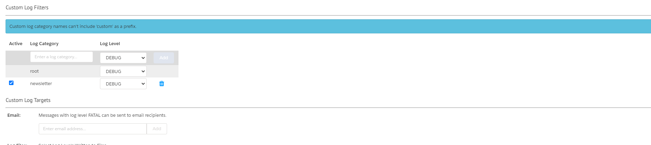

**Day-17**

1. Implement any free service using the service Framework
2. Implement the Currency Conversion service in your site using the service framework



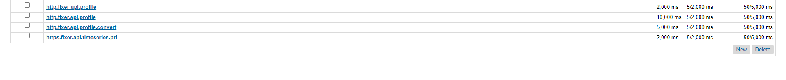



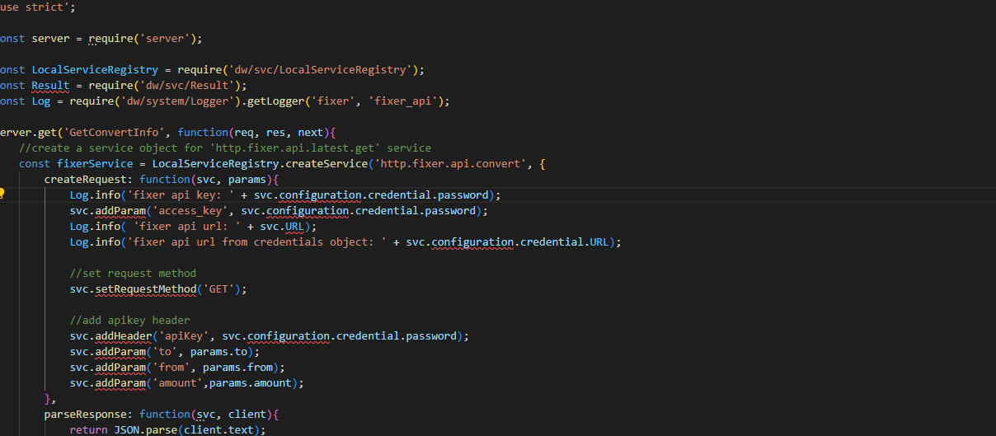

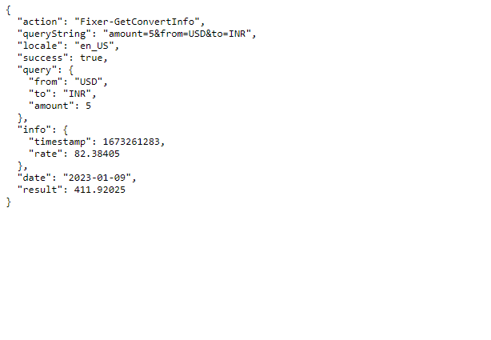

**Day-18**

1. Create a job and import customers using the system job step

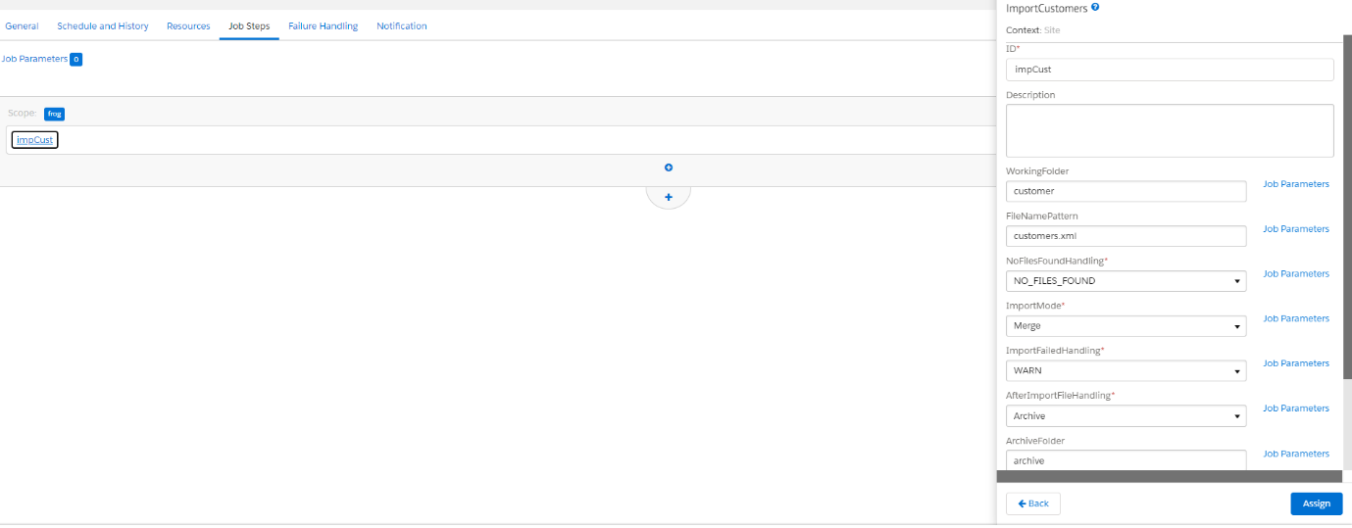

1. Rebuild the Search Index for your site using the system job step

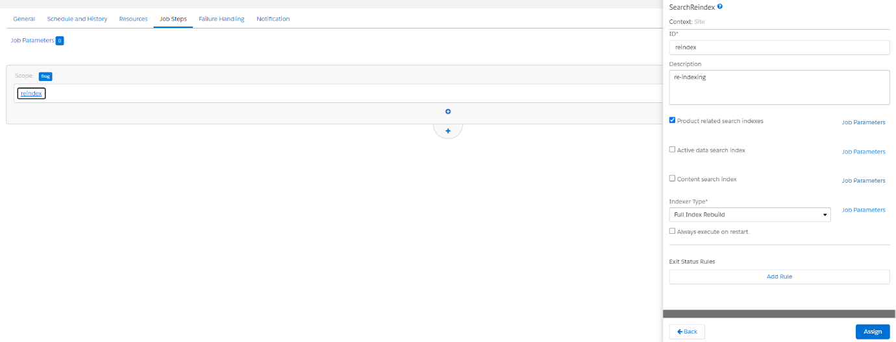

1. Import a new site into your sandbox using the job

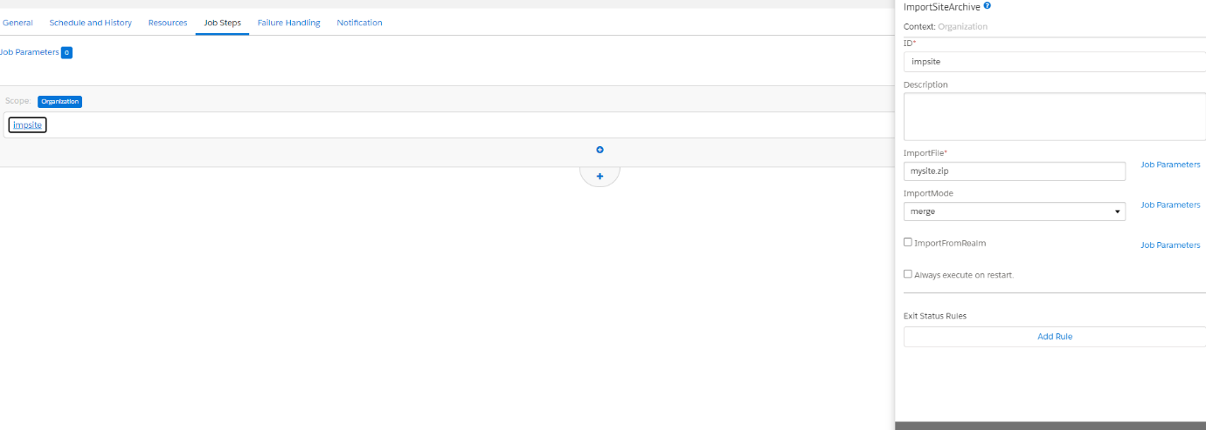

1. Create a custom job step to download a file from a WebDAV server
2. Create a custom job step to delete a file from a WebDAV server

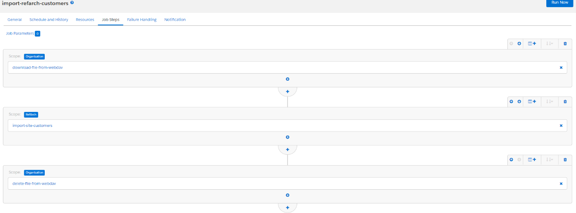

**Day-19&20**

1. Configure OCAPI settings to grant permissions to some shop and data APIs for the above client id

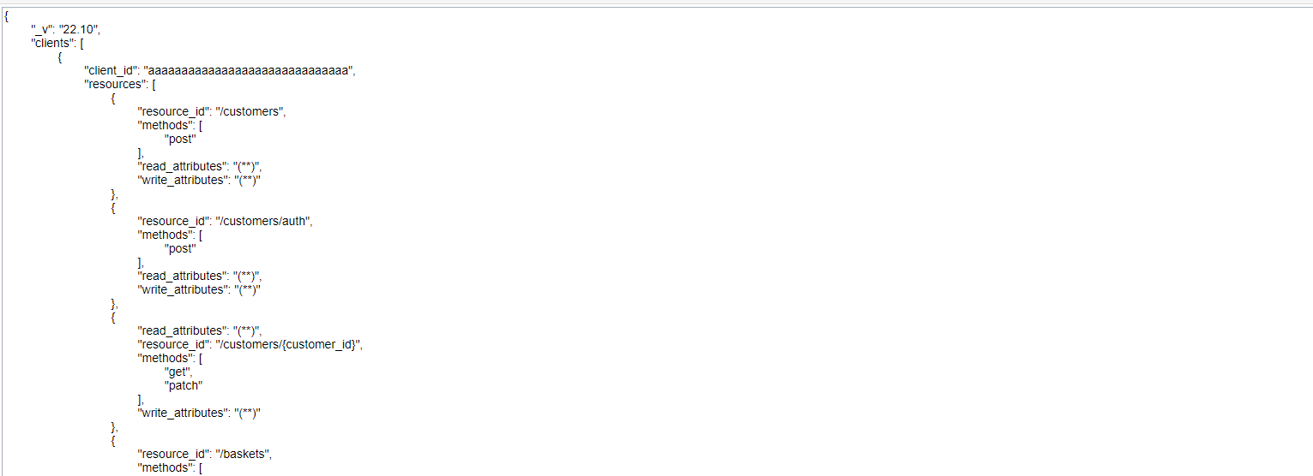

1. Generate a JWT token for a guest user

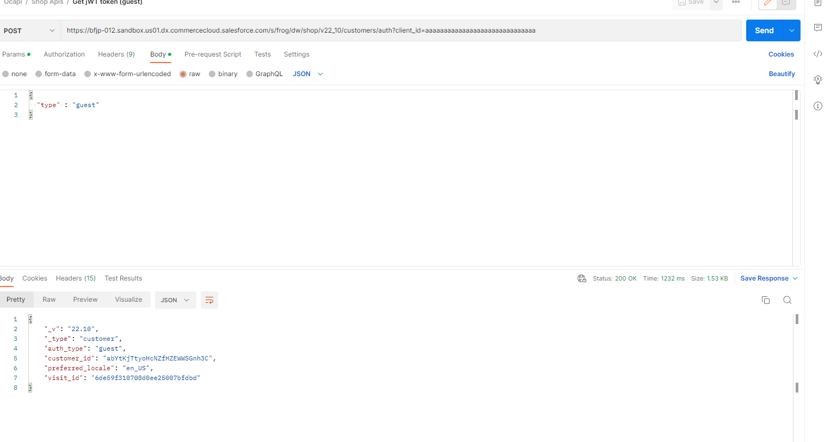

1. Generate a JWT token for a registered user

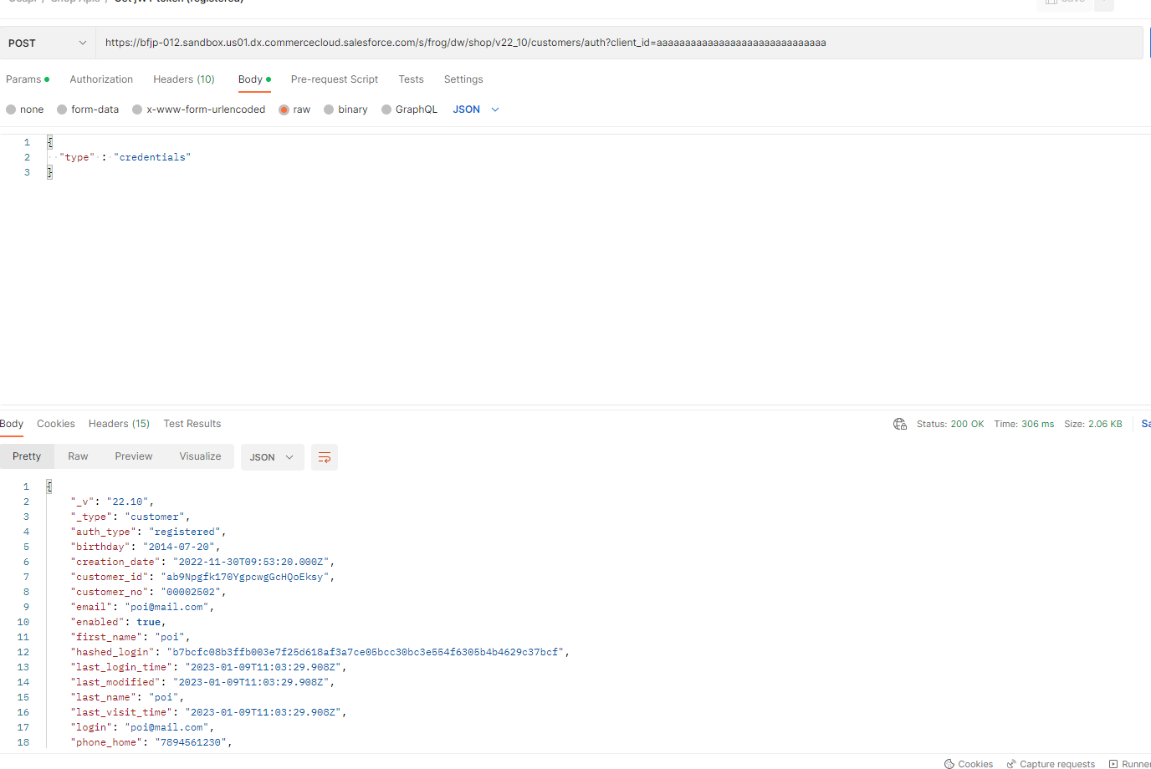

1. Generate an OAuth Token for grant type “client credentials”

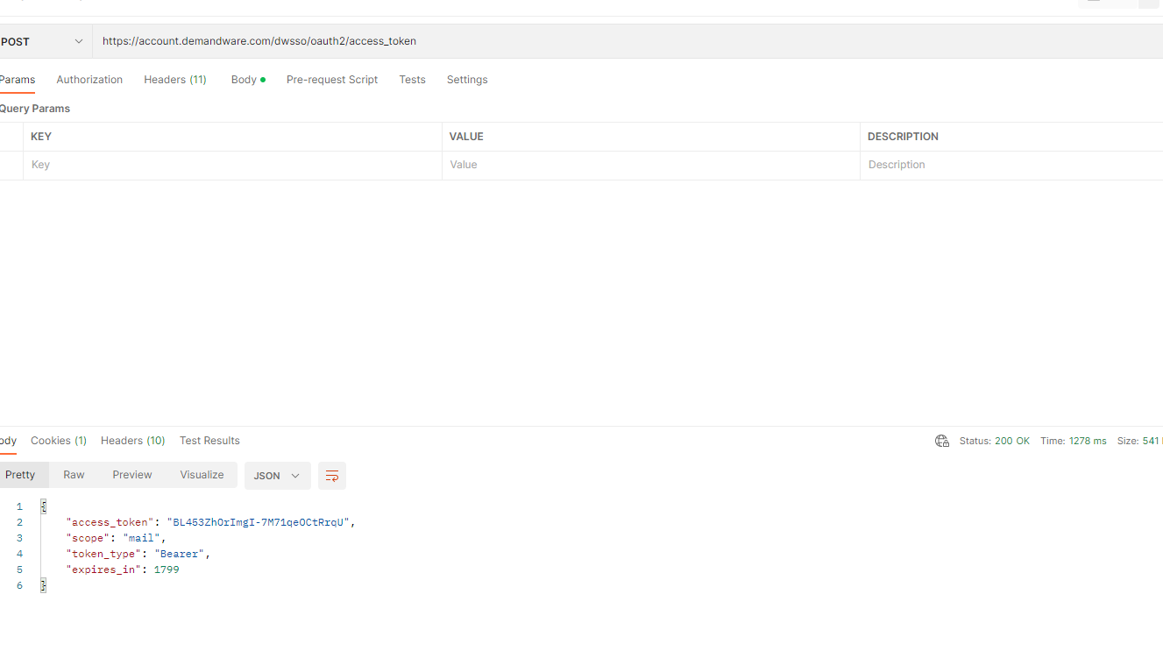

1. Generate an OAuth Token for a BM user

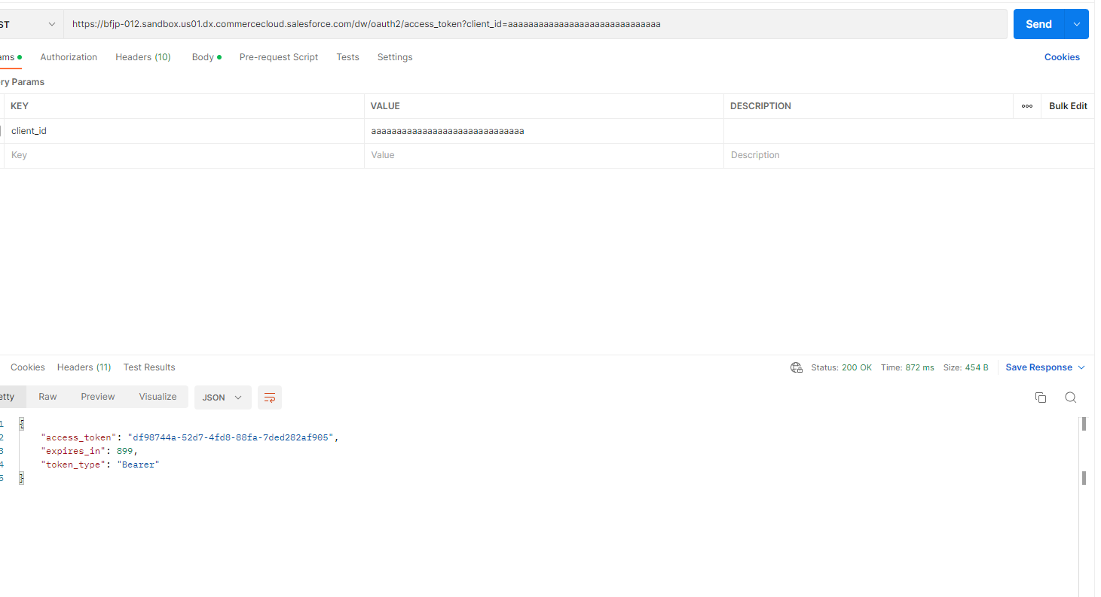

1. Simulate the process of accessing the APIs using the postman tool
   1. Get Product Resource

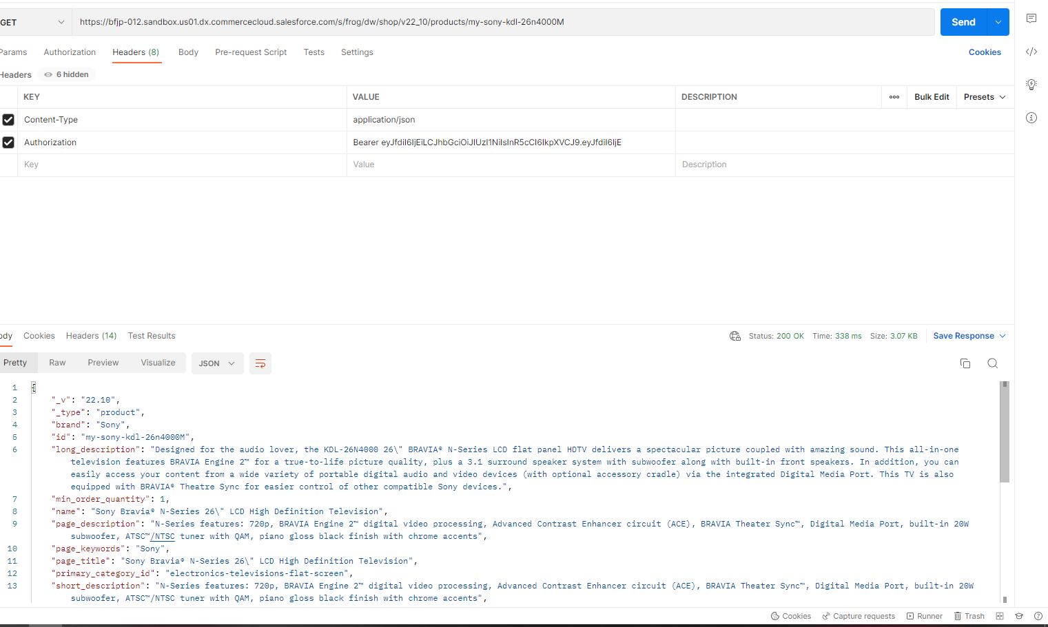

* 1. Create Basket Resource

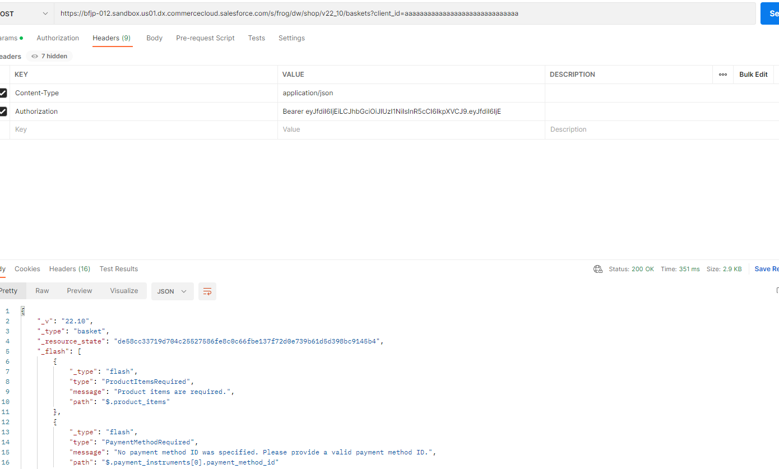

* 1. Add Product to Basket Resource

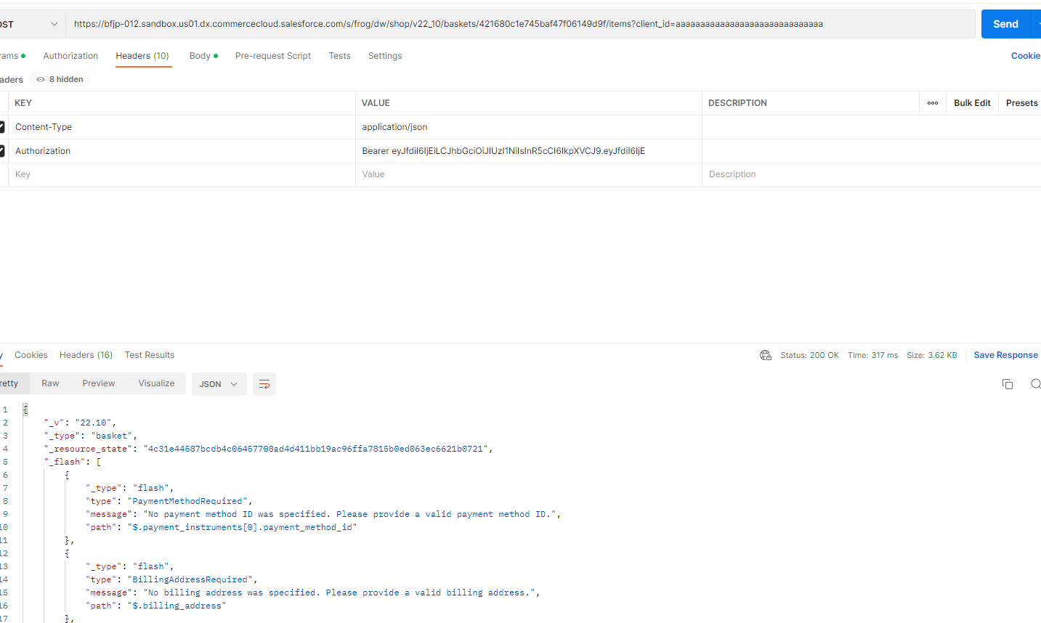

* 1. Create Customer Resource

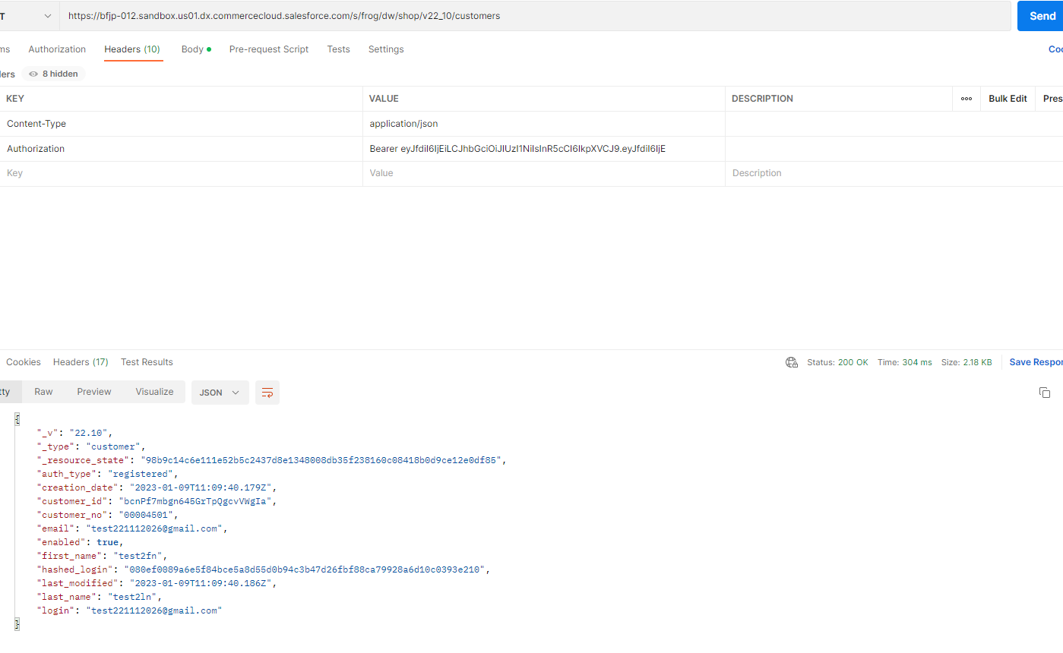

* 1. Get Catalog Info Resource

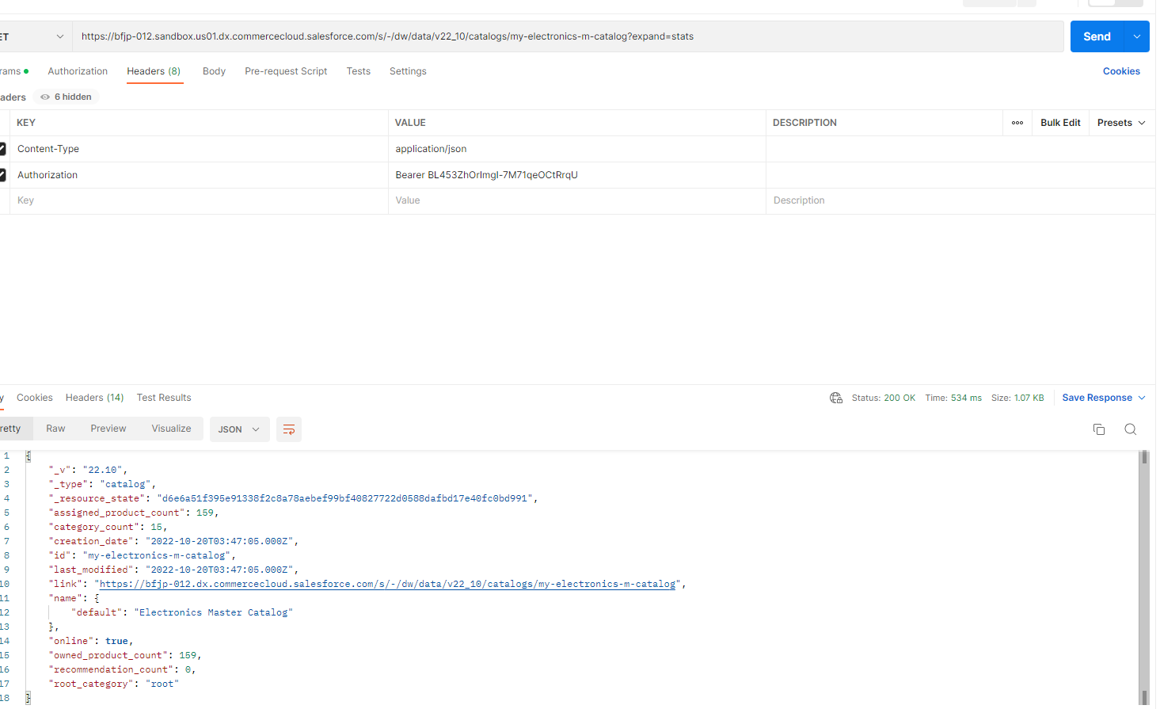

1. Implement any OCAPI hook

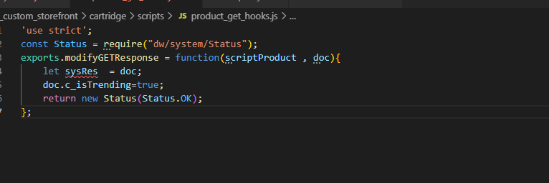

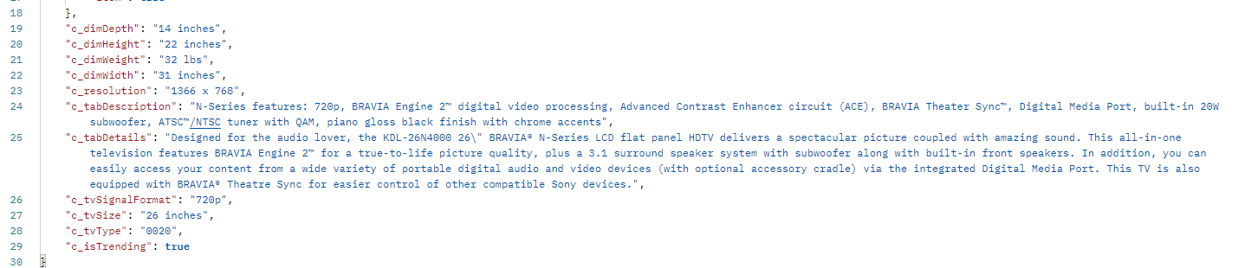

1. Implement a custom hook to print hello world message

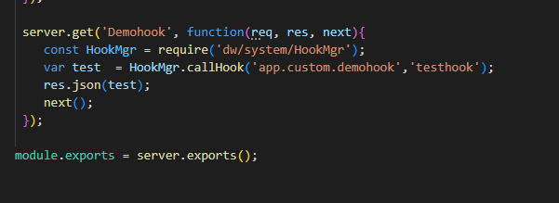

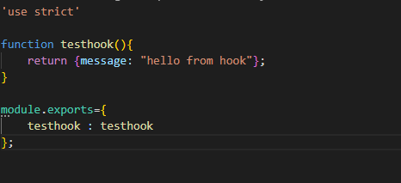

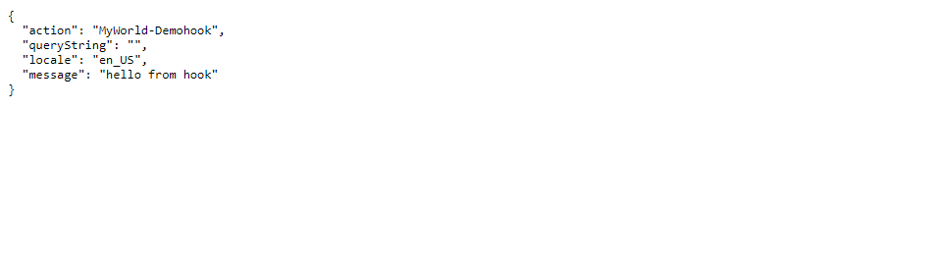

**Main-Project**

**Extend Profile Form :-**

